ChooseForm.vb
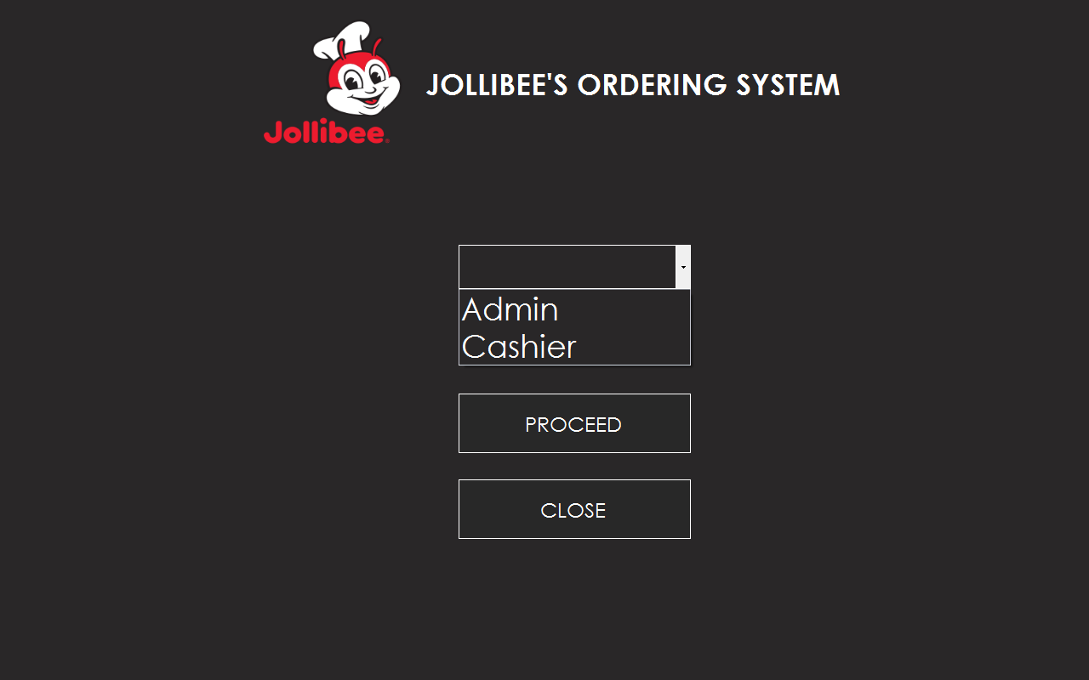
Login Form has 2 users, the admin and cashier. Let’s proceed to admin first.
AdminLoginForm.vb
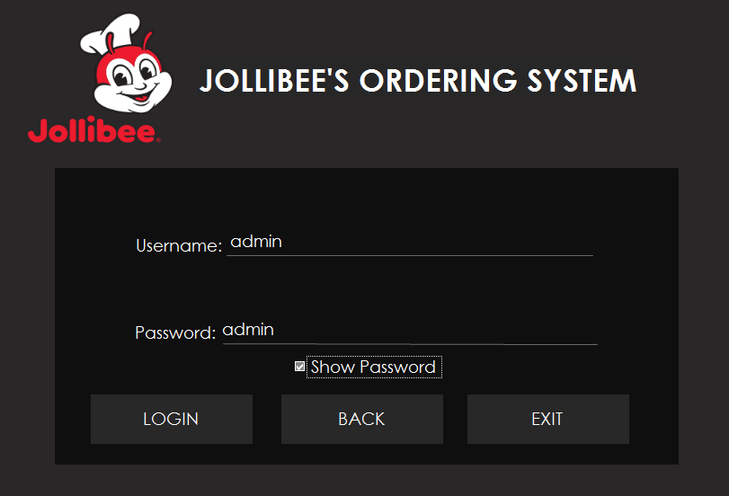
Username Textbox: admin
Password textbox: admin
Warning: If you fail to log in 3 times, the program will automatically close.
TransactionForm.vb
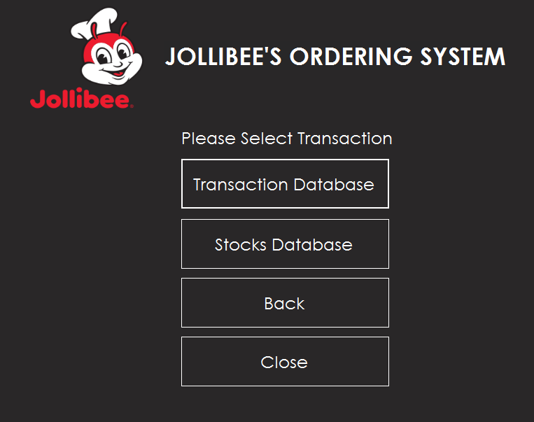
After you logged in, you will see the 2 database of system, the transaction database and stocks database. Let’s proceed to transaction database first.
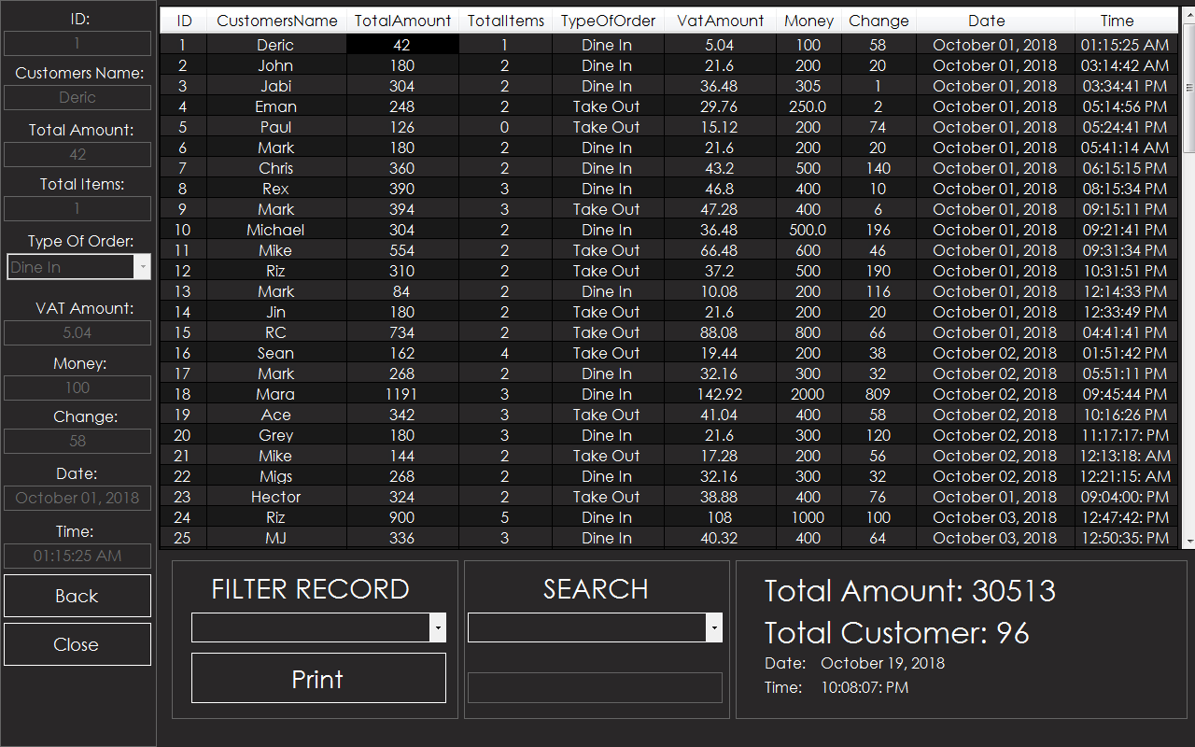
TransactionDatabase.vb
As you see, the Transaction Database holds all the records of customer’s order. Every time you clicked the row, the record appears at selected textbox.
Transaction database has different functions, the Filter Record, Print and Search.
At Filter record, you will see 4 options, the Normal, Daily, Weekly and Monthly. 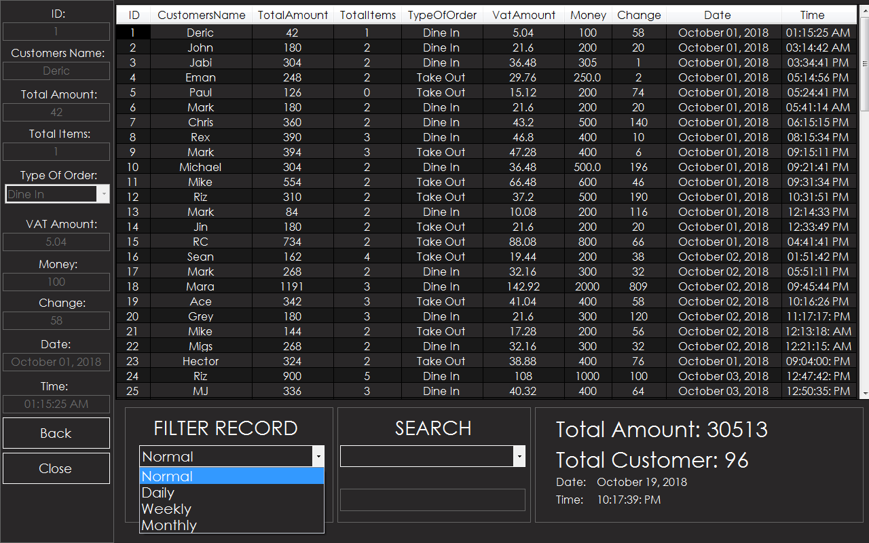
Normal – It will display all the records starting from the first up to the current record.
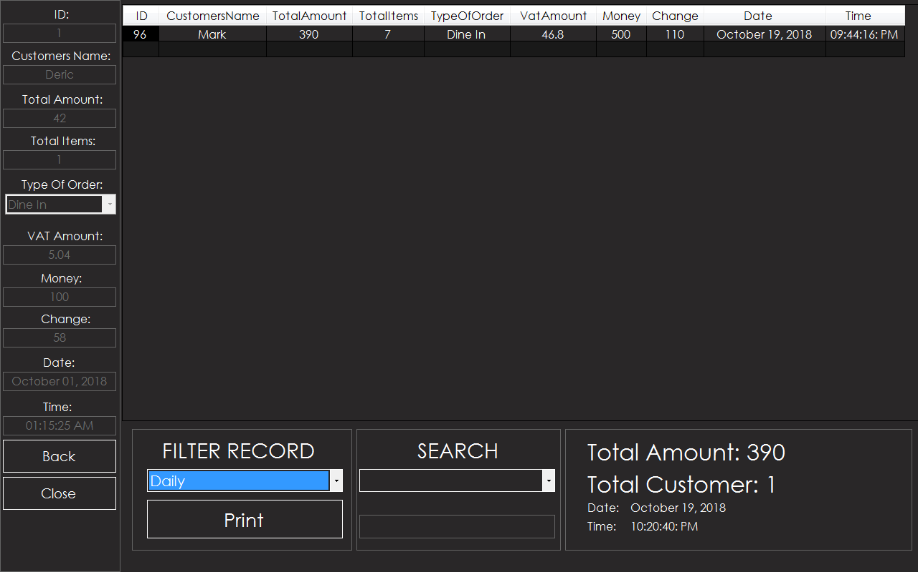
Daily – It will display the daily record. Every time you change the filter record, the total amount and Total Customer fetches the data depending on option you selected.
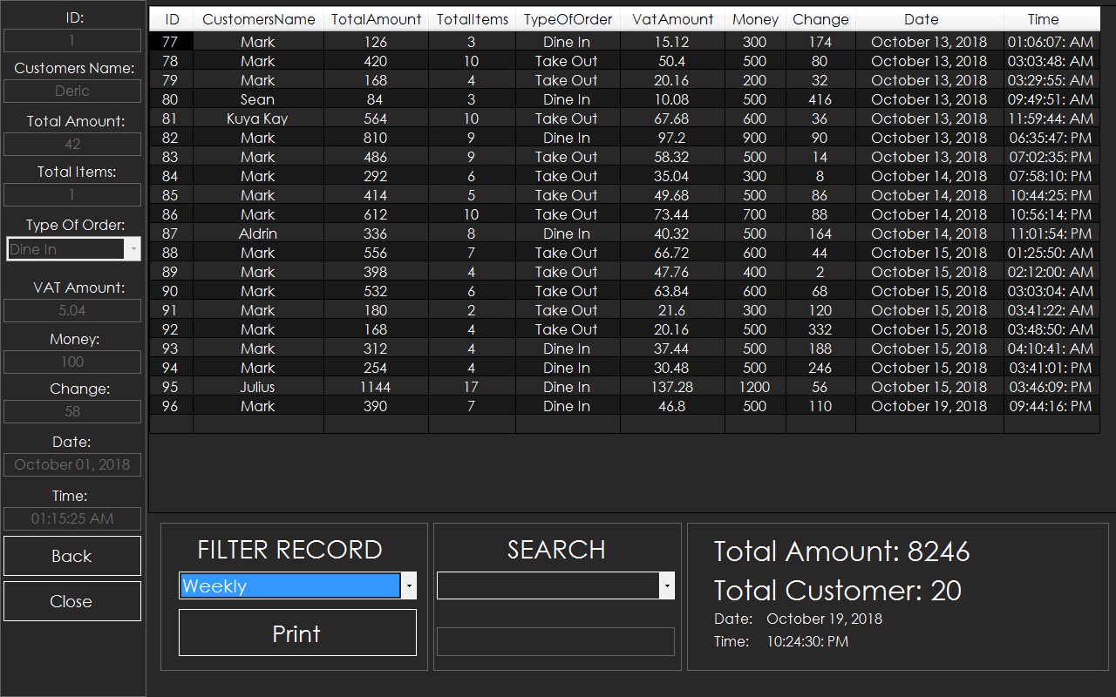
Weekly – It will display the record 7 days ago up to the daily record. The Total Amount and Total Customer fetches the data too same as Daily option.
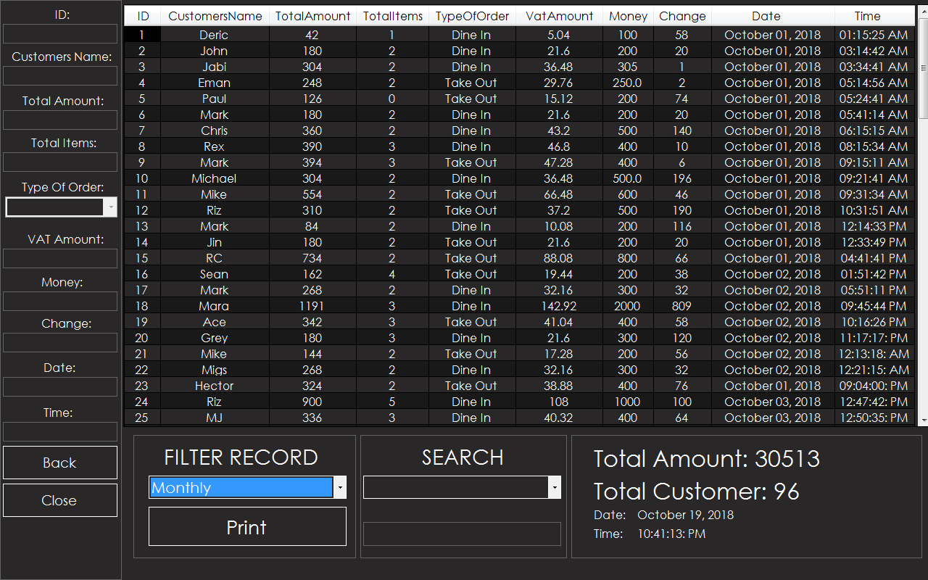
Monthly – There is no changes between Normal and Monthly. It’s because the starting Date of record is from October 01, 2018. It selects from 1 month ago up to current date.
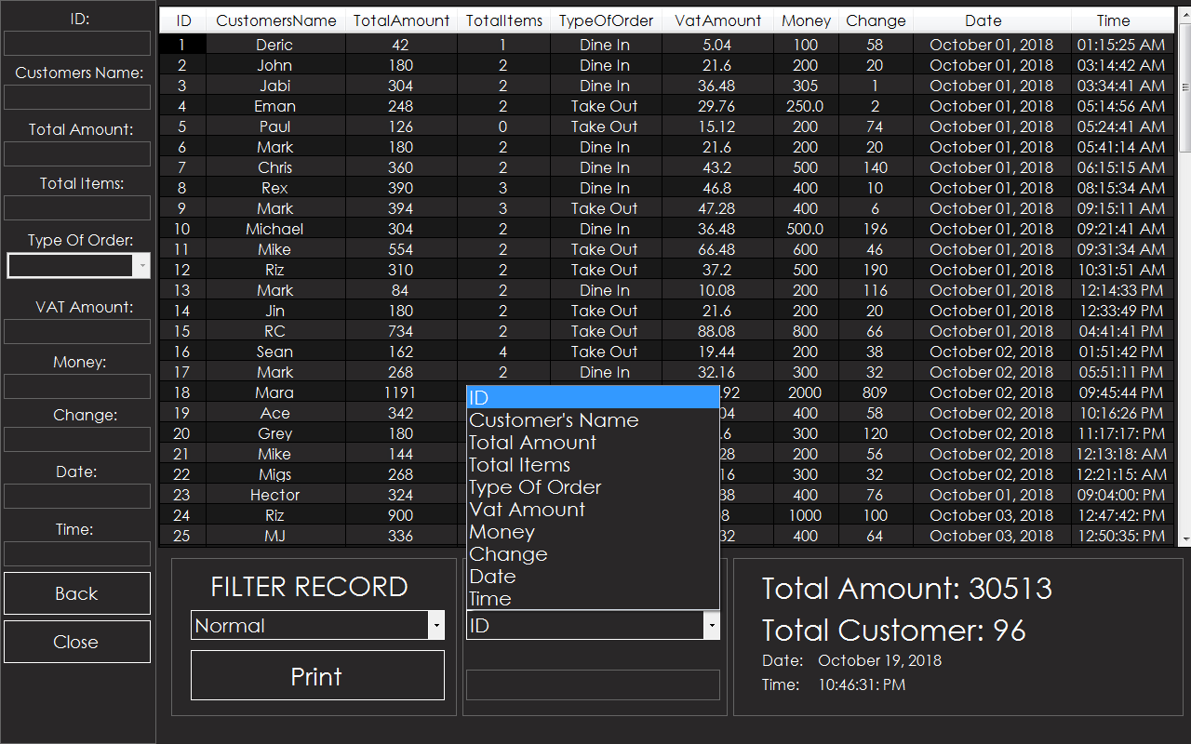
The Search function has options depending at column what you want to search.
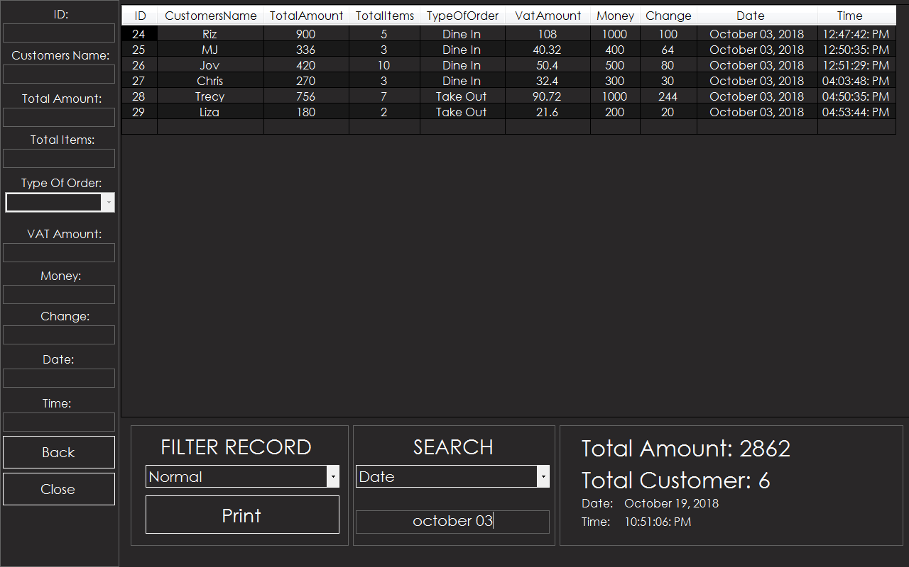Example, you want to search from date column, if you input the specific date you want to search, the record will display depends on what you inputted at search textbox.
The option ‘date’ is same to the other options at Search ComboBox.
Print - it prints all the data of DataGridView.
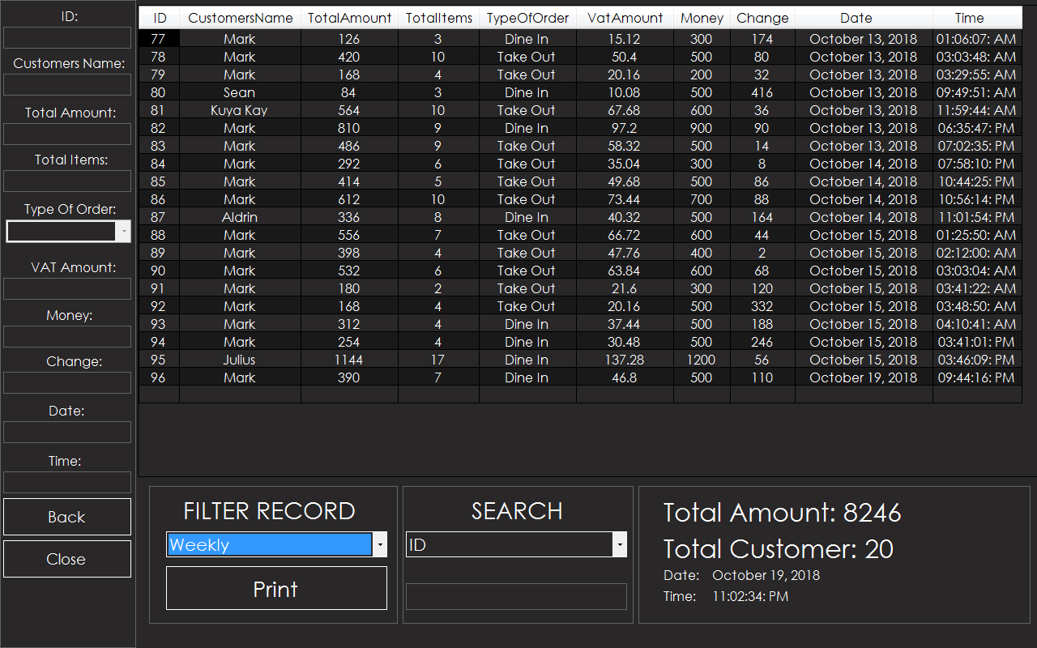
Example, you select the option ‘Weekly’ at Filter Record and you want to print all the data 7 days ago up to the current date, the record will display at crystal report like this.
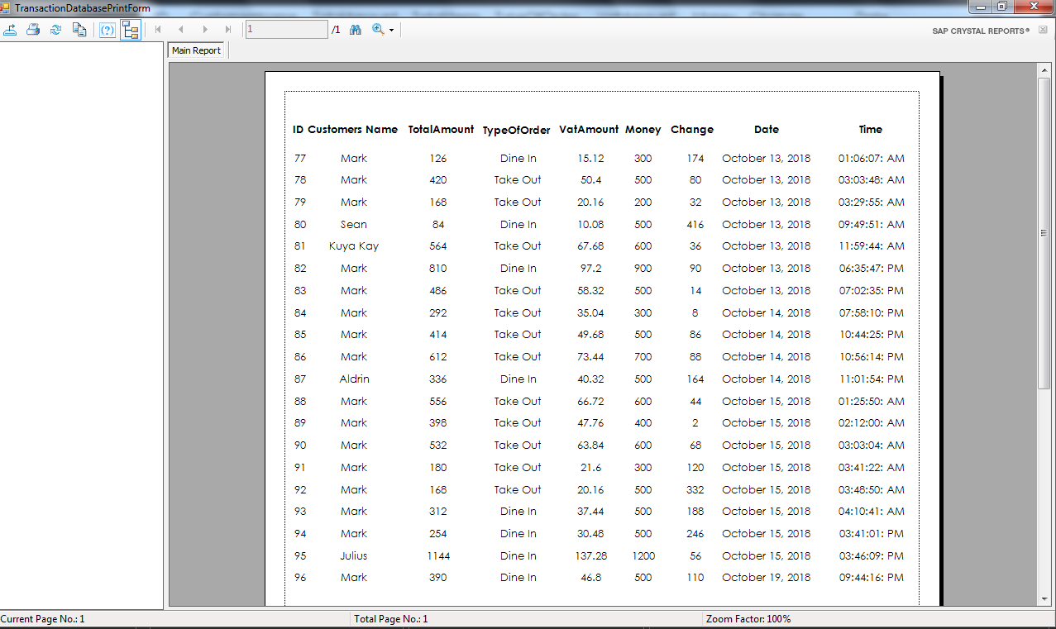
It prints the record depending at data of DataGridView.
StocksForm.vb
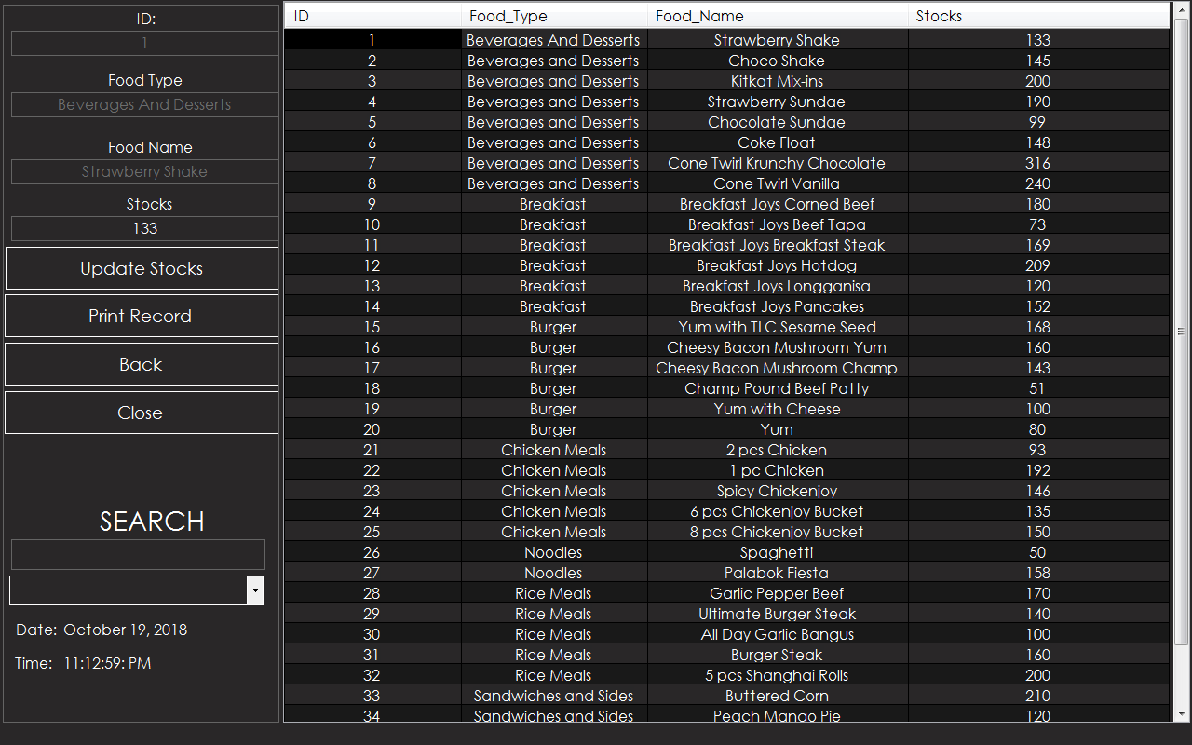
Stocks Form – It records the Stocks of all Items.
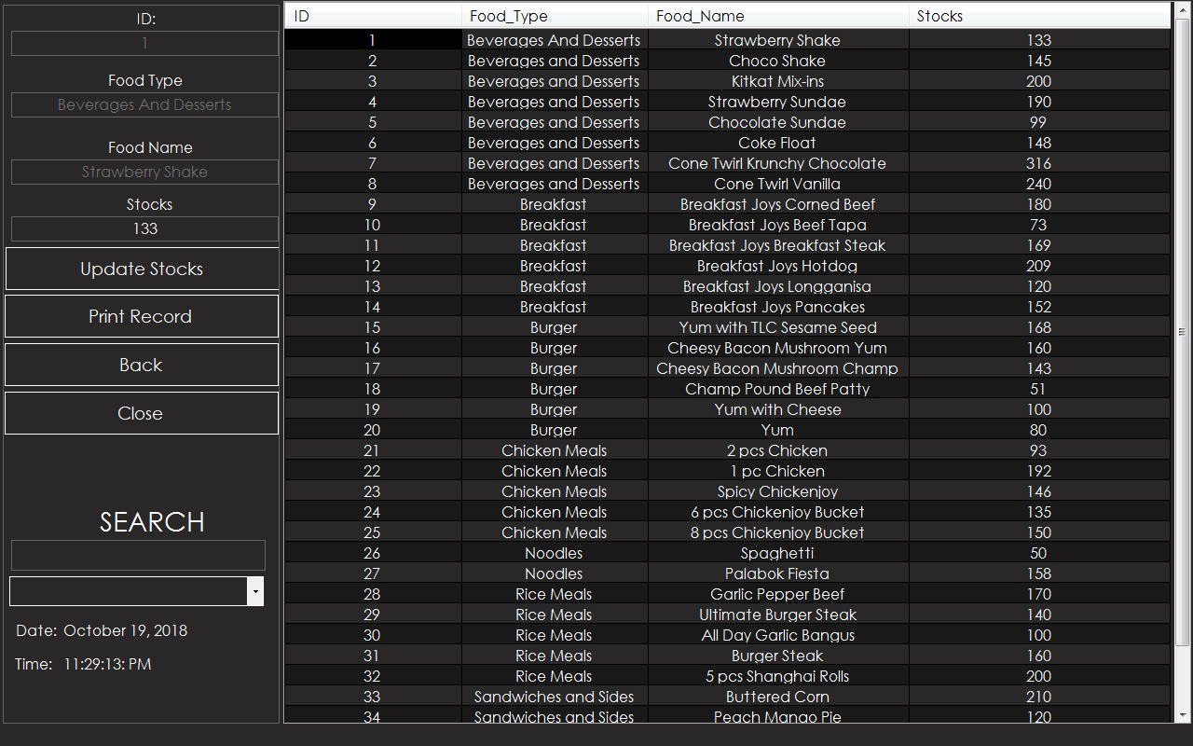
Update Stocks – It updates the current stocks of item. First, select the row of what item you want to update. (Ex: Strawberry Shake – Current Stocks: 133)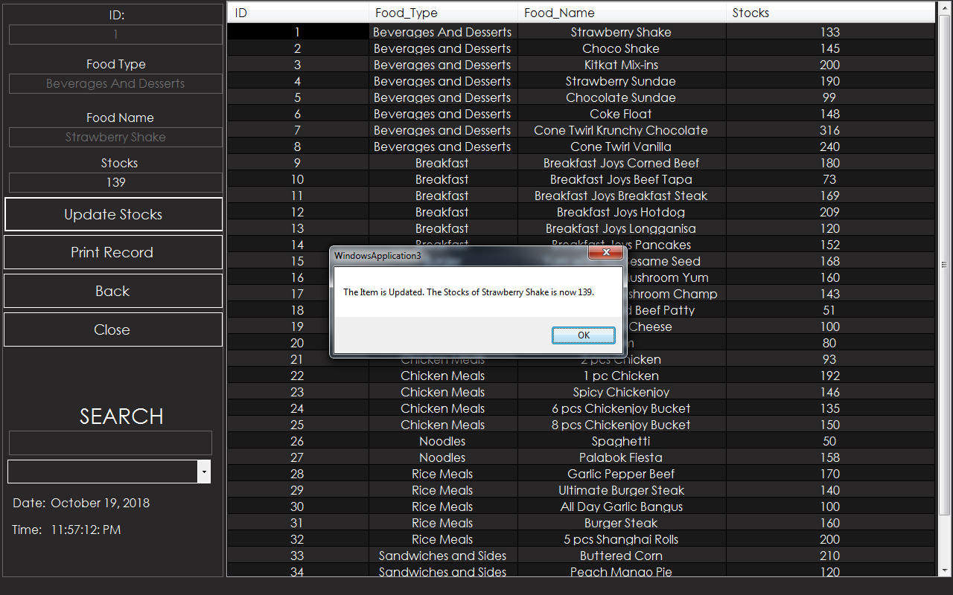After Choosing the row of item what you want, the stocks of item you choose will update the stocks. (Updated Stocks: Strawberry Shake – 139)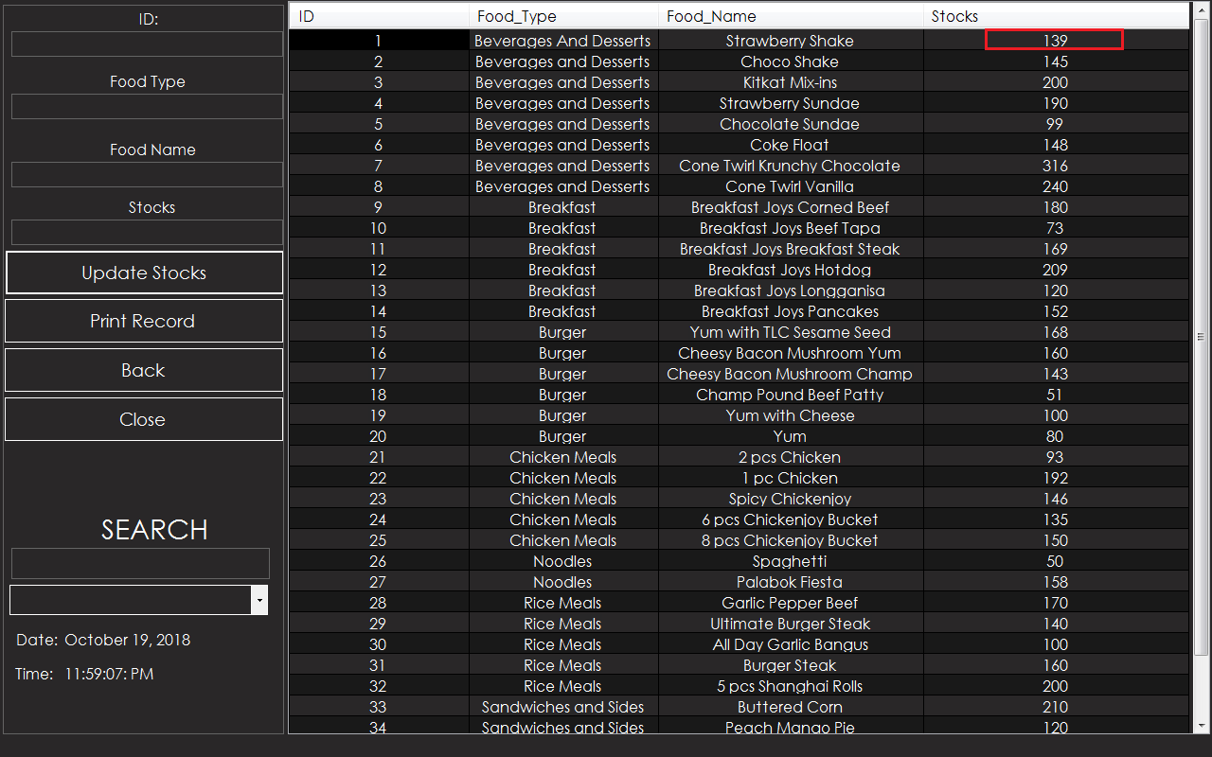
This is now the updated stocks of the item you select.
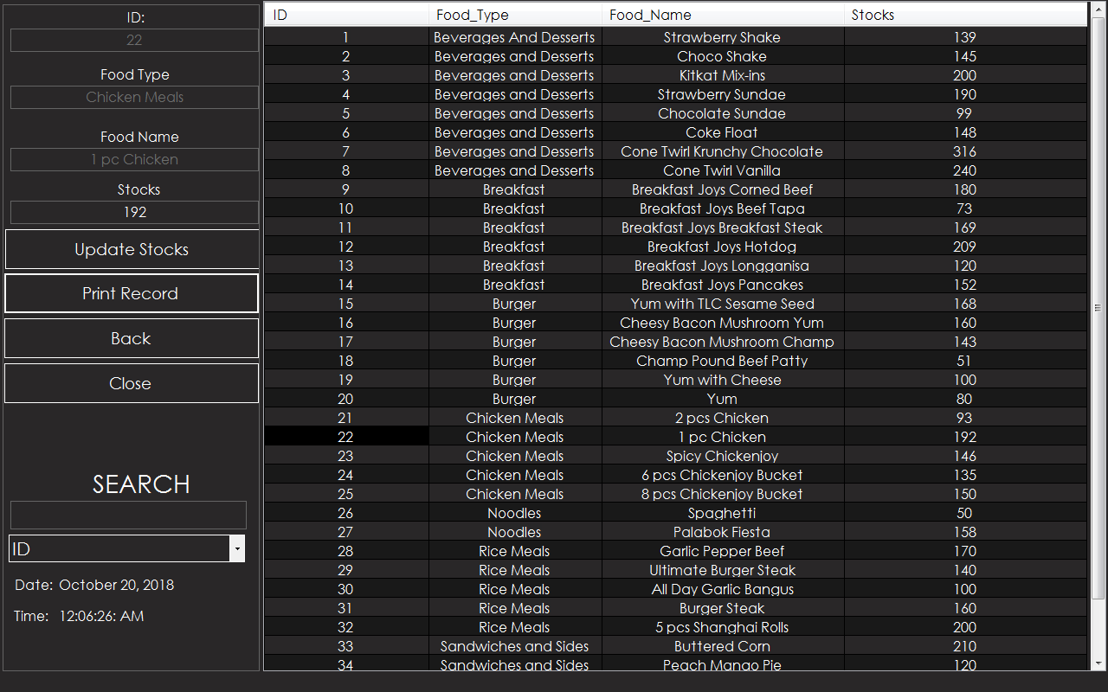Print Record - it prints all the data of DataGridView.
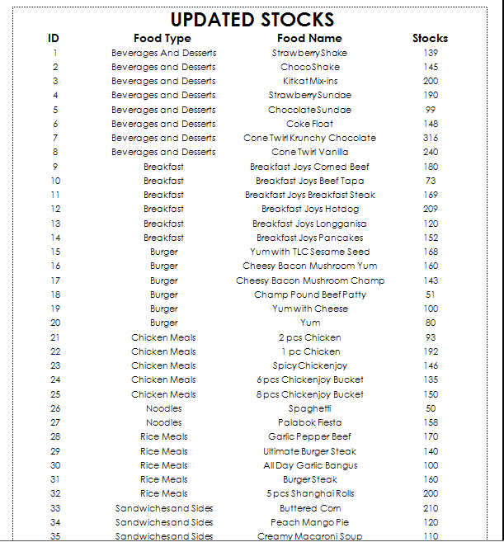
SEARCH – Appears the record depending on option and what you input at textbox.
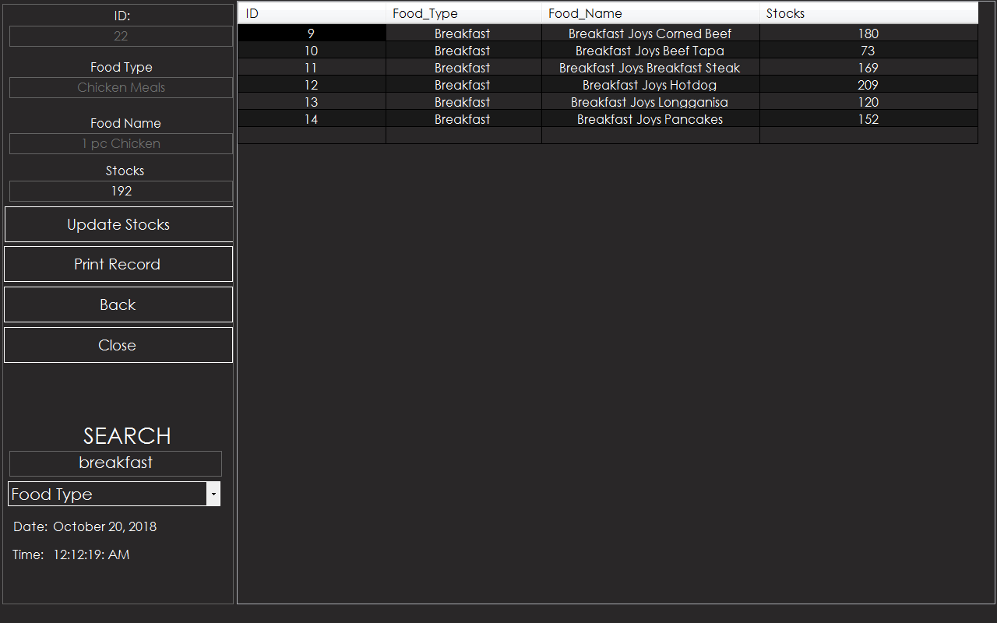
Example: At the option Food Type you want to search Breakfast, all the Food Type Breakfast will Appear.
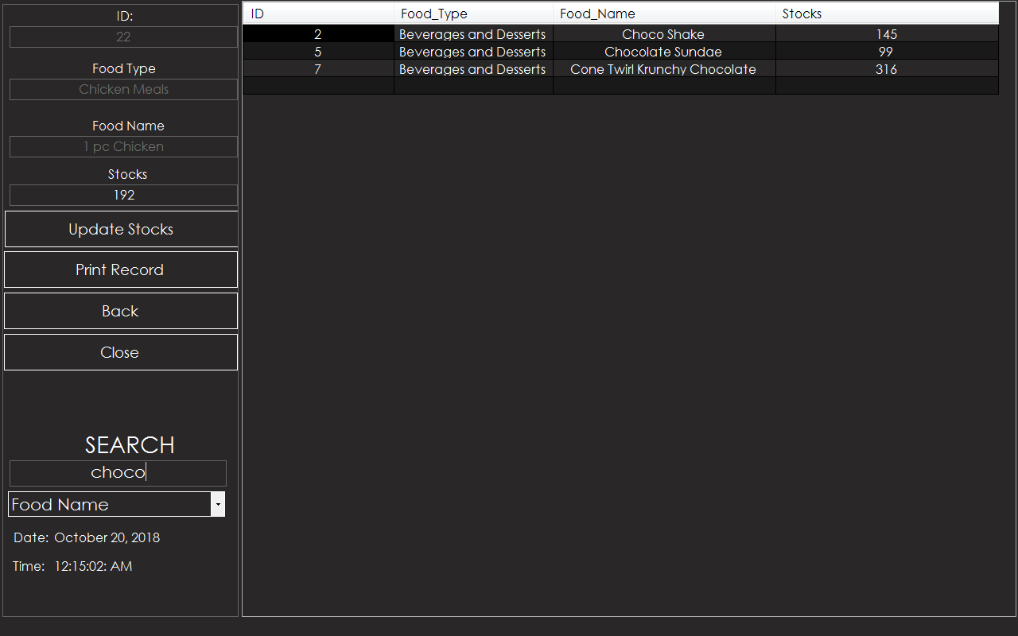
Same as option Food Name. If you want to search the specific food name (Ex: Choco) you want, all the word Choco will appear.
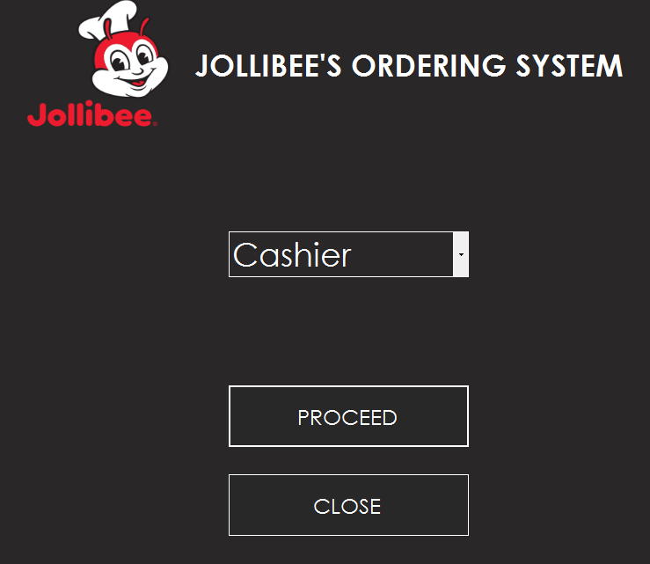
Now, let’s go back to Choose Form and proceed to Cashier’s Form.
CashierLogin.vb
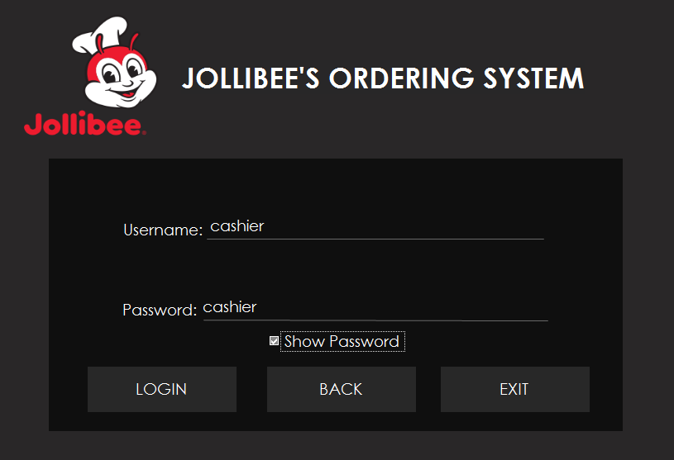
Username Textbox: cashier
Password textbox: cashier
Warning: If you fail to log in 3 times, the program will automatically close.
OrderForm.vb
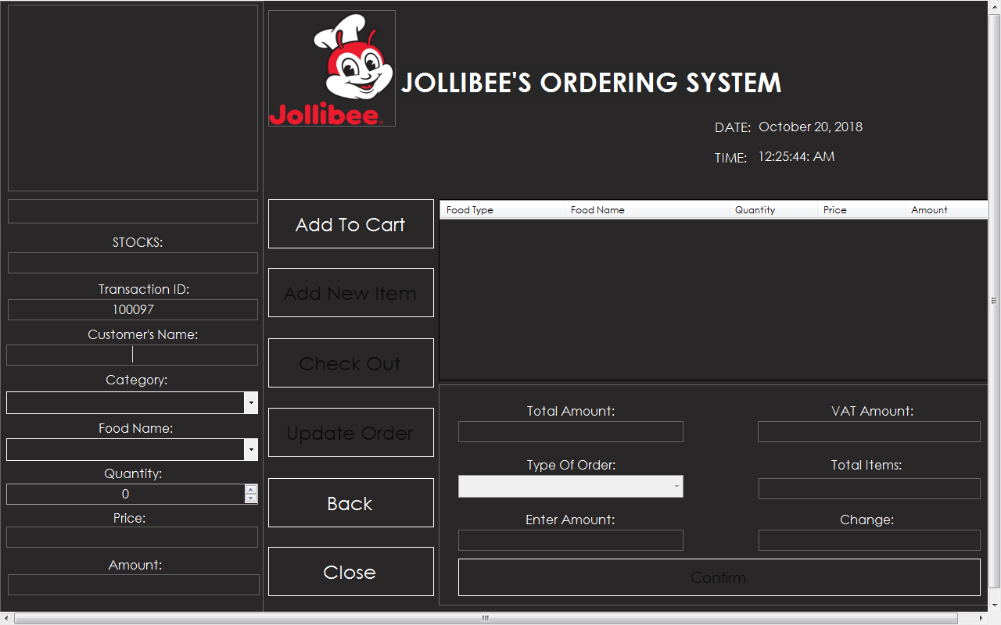
This is the form where the transaction happens. This could be the main form of system.
You need to Fill up all the fields first.
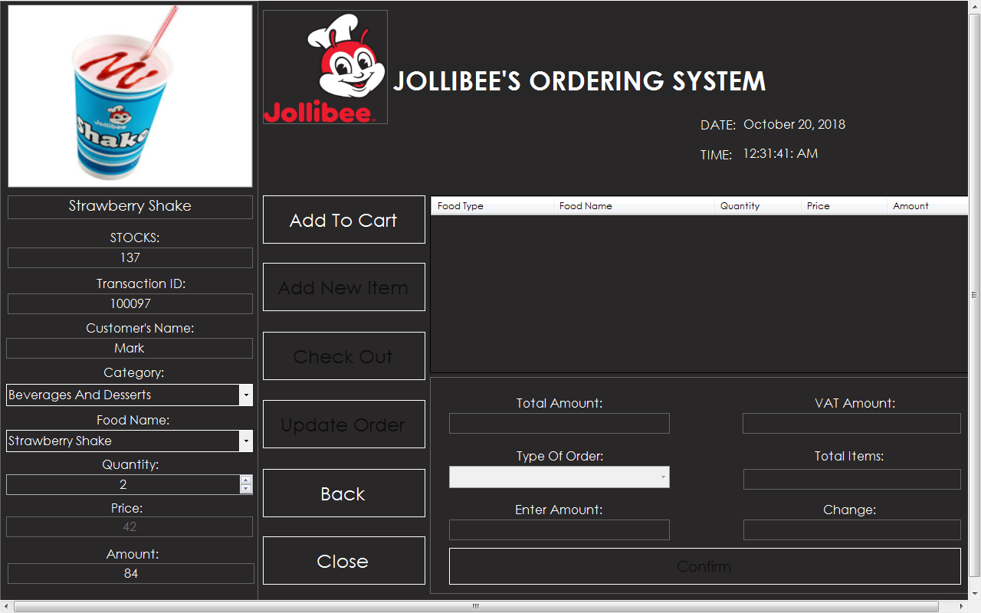
After you filled up name, you can now proceed on what items you want to order. Ex: You want to order Strawberry Shake, choose the Category ‘Beverages and Desserts’ and Food Name ‘Strawberry Shake’. NumericUpDown handles the Quantity of How many Items what you want to order.
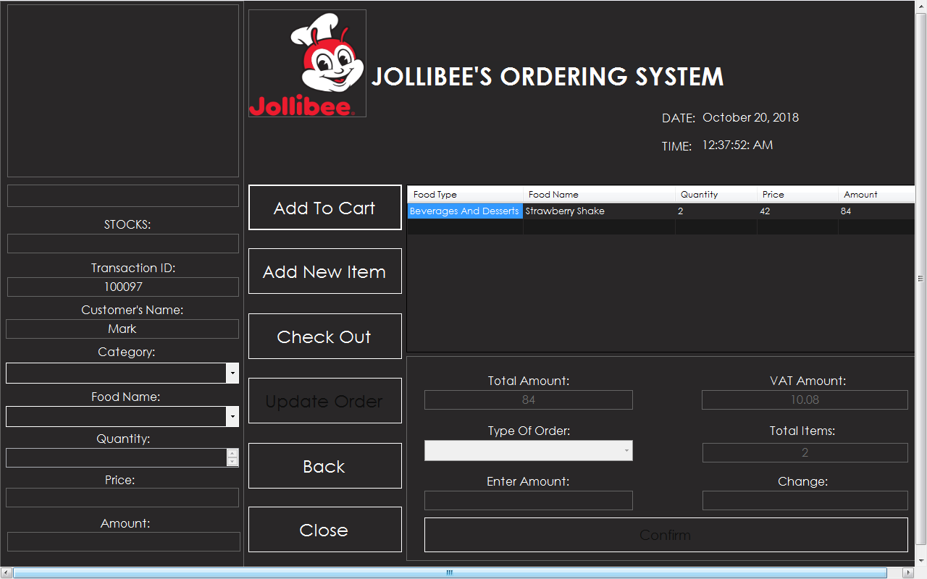
After clicking Add To Cart button, all the fields automatically added to Data Grid View. It also calculate the exact Total Amount, VAT Amount and Total Items of your order.
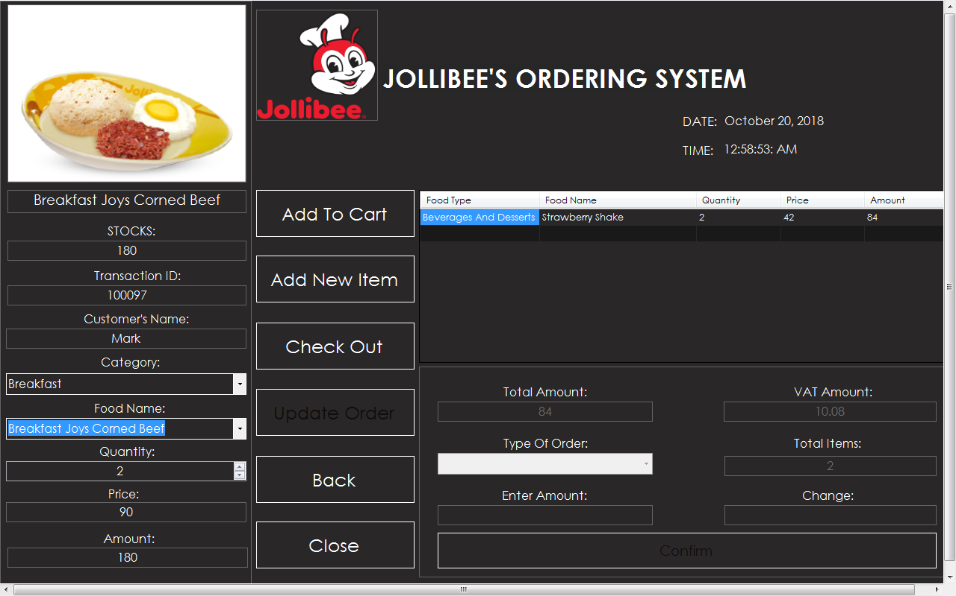
If you want to add another item, just click Add New Item button.
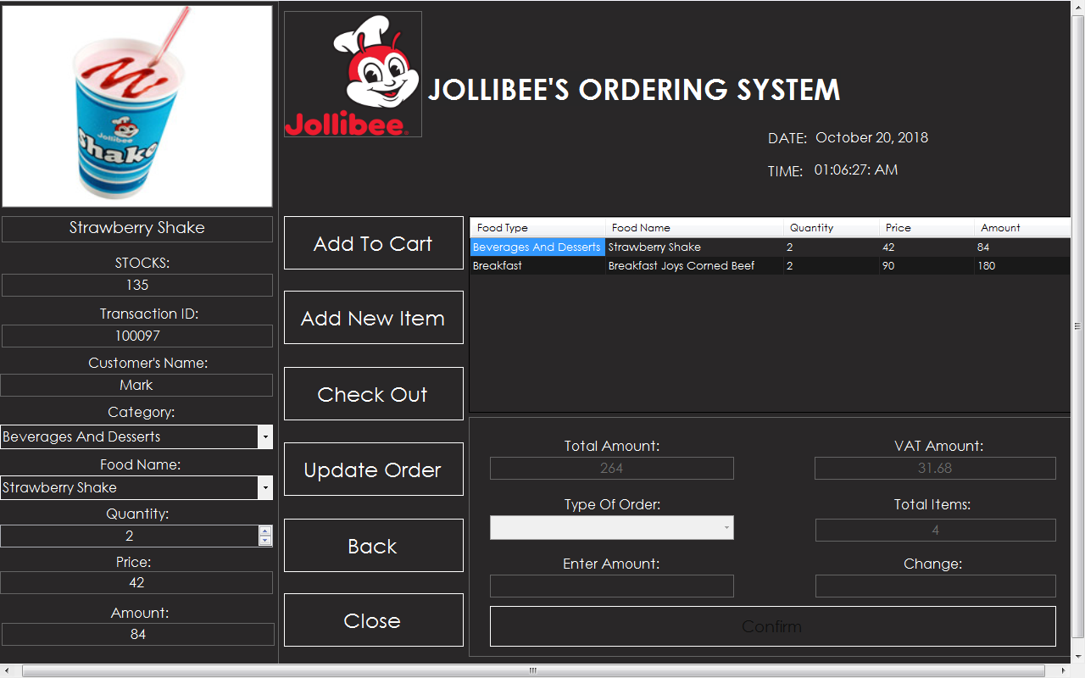
As you can see, we have 2 items at DataGridView. Let’s say you want to add more quantity at Food Strawberry Shake, just click the row and it will automatically appears at field. I want my quantity of Strawberry Shake make 5. After changing it at NumericUpDown (Quantity), click the Update Order
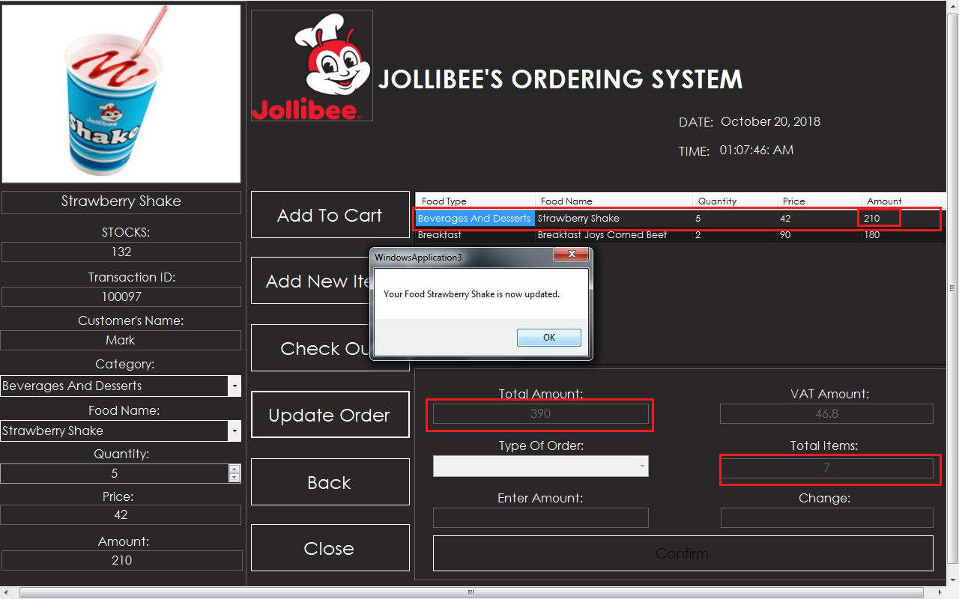
As you can see, the quantity, total amount and total items are now updated.
Now, I’m finally done with my order and I want to get my receipt now.
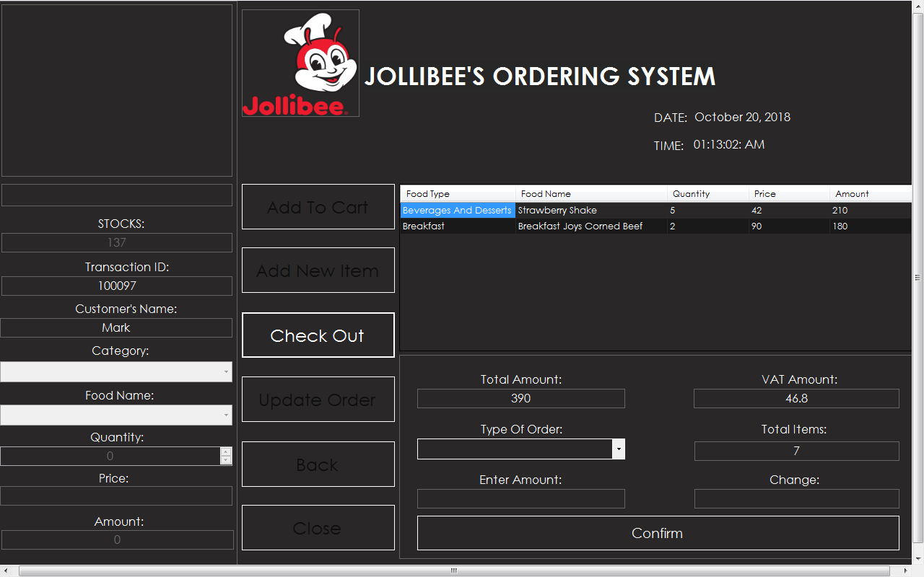
After Clicking the Check Out button, you will now proceed here. At Type of Order, the Cashier will ask you if you want your order to Dine In or Take Out. At Enter Amount, the cashier will input your money.
Let’s say I chose Dine In and my Amount is 500,
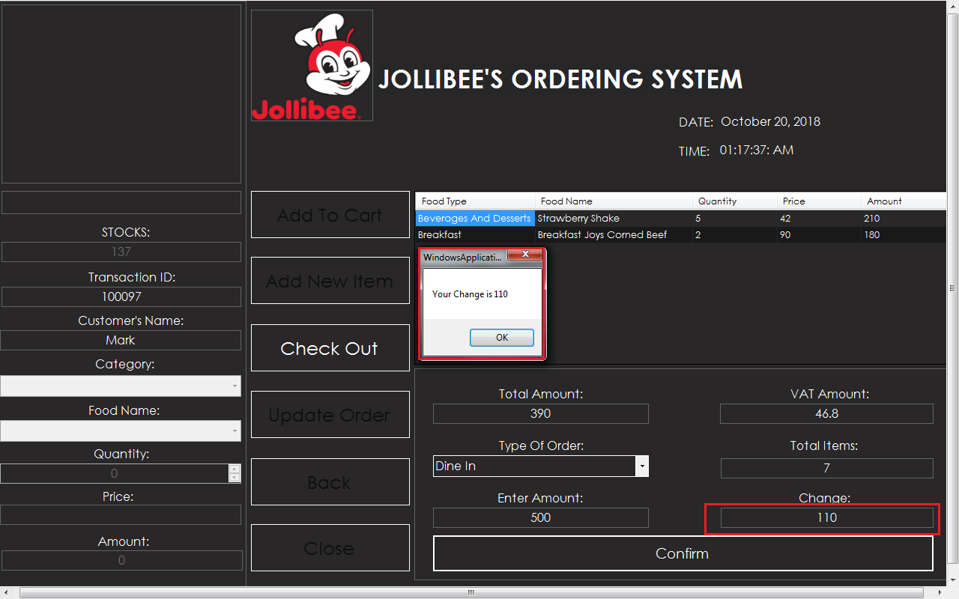
To Finalize your order, click the button Confirm. And you see the change appears at message box and calculates your amount to total amount of what you ordered.
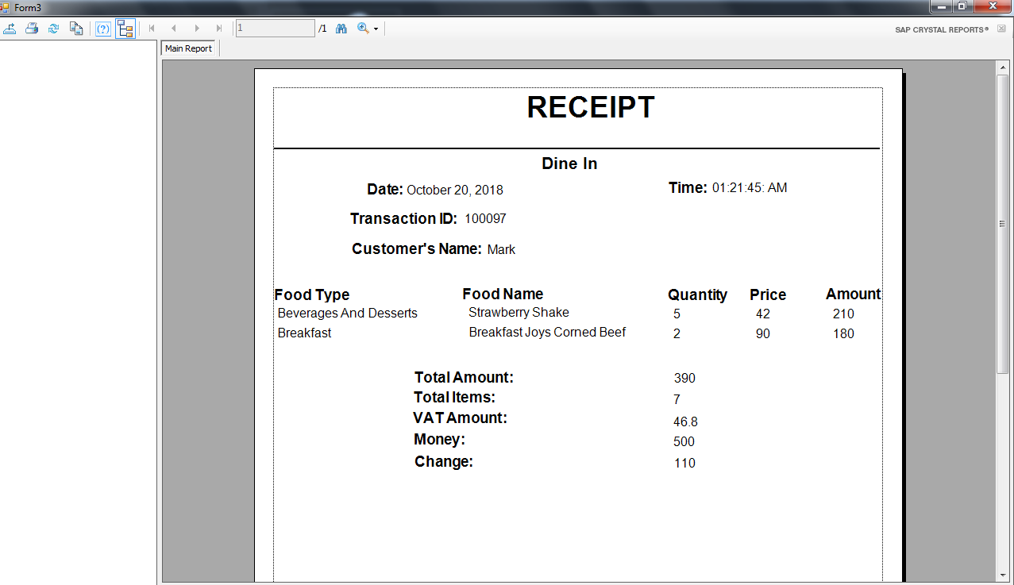You can now get your Receipt to see the items of what you ordered.
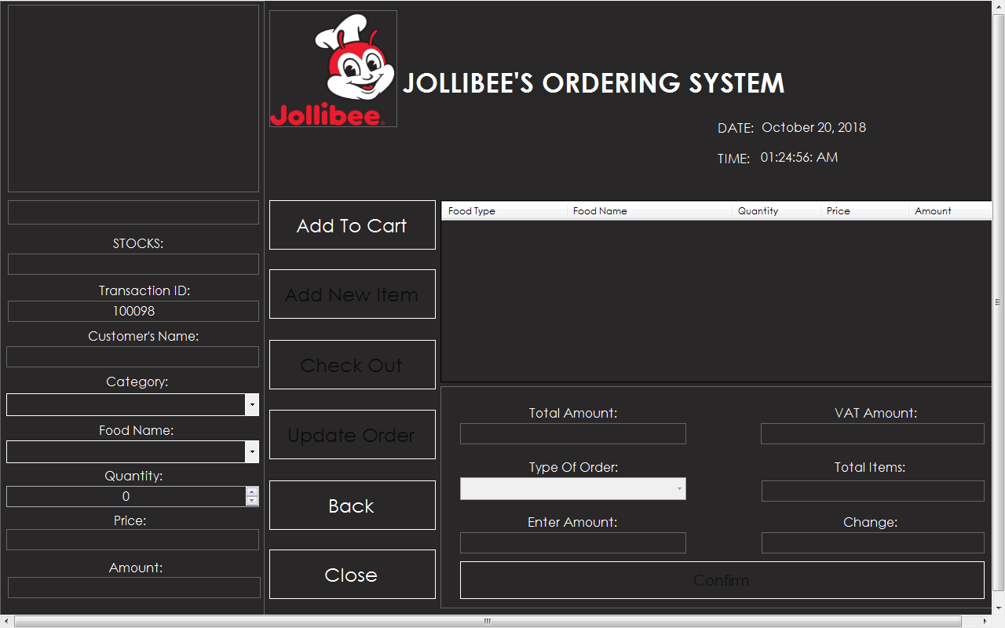
The Confirm button has function Refresh so you can now proceed to your New Customer. You don’t need to close program because the program refreshes the field and the Transaction ID automatically generates.
SOURCE CODE: ChooseForm.vb

Public Class ChooseForm
Private Sub Button1_Click(ByVal sender As System.Object, ByVal e As System.EventArgs) Handles Button1.Click
If ComboBox1.SelectedIndex = 0 Then
AdminLoginForm.Show()
Me.Hide()
ElseIf ComboBox1.SelectedIndex = 1 Then
CashierLogin.Show()
Me.Hide()
End If
Me.Controls.Clear() 'removes all the controls on the form
InitializeComponent() 'load all the controls again
ChooseForm_Load(e, e)
End Sub

Private Sub ChooseForm_Load(ByVal sender As System.Object, ByVal e As System.EventArgs) Handles MyBase.Load
Me.WindowState = FormWindowState.Maximized
End Sub
Private Sub Button2_Click(ByVal sender As System.Object, ByVal e As System.EventArgs) Handles Button2.Click
Close()
End Sub
End Class

SOURCE CODE: AdminLoginForm.vb
Public Class AdminLoginForm
Dim attempt As Integer = 1
Dim settings As New My.MySettings()

Private Sub Button1_Click(ByVal sender As System.Object, ByVal e As System.EventArgs) Handles Button1.Click
Dim username, password As String
username = TextBox8.Text
password = TextBox1.Text

If username = "admin" And password = "admin" Then
MessageBox.Show("Login Successful!", "System Information", MessageBoxButtons.OK, MessageBoxIcon.Information)
Me.Hide()
TransactionForm.Show()
ElseIf attempt = 3 Then
MessageBox.Show("Maximum number of Attempts (3). The Program will now close. ", "System Error", MessageBoxButtons.OK, MessageBoxIcon.Error)
Close()
Else
MessageBox.Show("Incorrect Username or Password. Please re-enter. You currently have reached attempt " & attempt & " of 3. "" ", "System Error", MessageBoxButtons.OK, MessageBoxIcon.Error)
attempt = attempt + 1
TextBox8.Text = ""
TextBox1.Text = ""
TextBox8.Focus()

End If

End Sub

Private Sub Button2_Click(ByVal sender As System.Object, ByVal e As System.EventArgs) Handles Button2.Click
Me.Close()
End Sub
Private Sub CheckBox1_CheckedChanged(ByVal sender As System.Object, ByVal e As System.EventArgs) Handles CheckBox1.CheckedChanged
If CheckBox1.Checked Then
TextBox1.UseSystemPasswordChar = False
Else
TextBox1.UseSystemPasswordChar = True
End If
End Sub

Private Sub LoginForm_Load(ByVal sender As System.Object, ByVal e As System.EventArgs) Handles MyBase.Load
TextBox8.Select()
Me.WindowState = FormWindowState.Maximized
End S
Private Sub TextBox8_Enter(ByVal sender As System.Object, ByVal e As System.EventArgs) Handles TextBox8.Enter
If (TextBox8.Text = "Password") Then
TextBox8.Text = ""
End If

End Sub

Private Sub TextBox8_Leave(ByVal sender As System.Object, ByVal e As System.EventArgs) Handles TextBox8.Leave
If (TextBox8.Text = "Password") Then
TextBox8.Text = ""
End If

End Sub

Private Sub Button3_Click_1(ByVal sender As System.Object, ByVal e As System.EventArgs) Handles Button3.Click
ChooseForm.Show()
Me.Hide()
Me.Controls.Clear() 'removes all the controls on the form
InitializeComponent() 'load all the controls again
LoginForm_Load(e, e)
End Sub
End Class

SOURCE CODE: CashierLogin.vb
Public Class CashierLogin
Dim attempt As Integer = 1
Dim settings As New My.MySettings()

Private Sub CheckBox1_CheckedChanged(ByVal sender As System.Object, ByVal e As System.EventArgs) Handles CheckBox1.CheckedChanged
If CheckBox1.Checked Then
TextBox1.UseSystemPasswordChar = False
Else
TextBox1.UseSystemPasswordChar = True

End If
End Sub

Private Sub Button1_Click(ByVal sender As System.Object, ByVal e As System.EventArgs) Handles Button1.Click
Dim username, password As String
username = TextBox8.Text
password = TextBox1.Text
If username = "cashier" And password = "cashier" Then
MessageBox.Show("Login Successful!", "System Information", MessageBoxButtons.OK, MessageBoxIcon.Information)
Me.Hide()
OrderForm.Show()
ElseIf attempt = 3 Then
MessageBox.Show("Maximum number of Attempts (3). The Program will now close. ", "System Error", MessageBoxButtons.OK, MessageBoxIcon.Error)
Close()
Else
MessageBox.Show("Incorrect Username or Password. Please re-enter. You currently have reached attempt " & attempt & " of 3. "" ", "System Error", MessageBoxButtons.OK, MessageBoxIcon.Error)
attempt = attempt + 1
TextBox8.Text = ""
TextBox1.Text = ""
TextBox8.Focus()

End If
Me.Controls.Clear() 'removes all the controls on the form
InitializeComponent() 'load all the controls again
CashierLogin_Load(e, e)
End Sub

Private Sub CashierLogin_Load(ByVal sender As System.Object, ByVal e As System.EventArgs) Handles MyBase.Load
Me.WindowState = FormWindowState.Maximized

End Sub
Private Sub Button2_Click(ByVal sender As System.Object, ByVal e As System.EventArgs) Handles Button2.Click
Me.Close()
End Sub
Private Sub Button3_Click_1(ByVal sender As System.Object, ByVal e As System.EventArgs) Handles Button3.Click
ChooseForm.Show()
Me.Hide()
Me.Controls.Clear() 'removes all the controls on the form
InitializeComponent() 'load all the controls again
CashierLogin_Load(e, e)
End Sub
End Class
SOURCE CODE: TransactionForm.vb
Public Class TransactionForm
Private Sub Button1_Click(ByVal sender As System.Object, ByVal e As System.EventArgs)
OrderForm.Show()
Me.Hide()
End Sub

Private Sub Button2_Click(ByVal sender As System.Object, ByVal e As System.EventArgs) Handles Button2.Click
TransactionDatabaseForm.Show()
Me.Hide()
End Sub

Private Sub Button3_Click(ByVal sender As System.Object, ByVal e As System.EventArgs) Handles Button3.Click
StocksForm.Show()
Me.Hide()
End Sub

Private Sub Button4_Click(ByVal sender As System.Object, ByVal e As System.EventArgs) Handles Button4.Click
Me.Close()
End Sub

Private Sub TransactionForm_Load(ByVal sender As System.Object, ByVal e As System.EventArgs) Handles MyBase.Load
Me.WindowState = FormWindowState.Maximized

End Sub

Private Sub Button1_Click_1(ByVal sender As System.Object, ByVal e As System.EventArgs) Handles Button1.Click
ChooseForm.Show()
Me.Hide()
End Sub
End Class

SOURCE CODE: TransactionDatabaseForm.vb
Imports System.Data.OleDb

Public Class TransactionDatabaseForm
Dim conn As OleDb.OleDbConnection
Dim da As OleDb.OleDbDataAdapter
Dim dt As DataTable
Dim cmd As OleDbCommand
Dim dbdata As OleDbDataReader
Dim index As Integer
ReadOnly CONNECTION_STRING As String = "Provider=microsoft.Jet.oledb.4.0; Data Source=" & _
Application.StartupPath.Replace("\bin\Debug", String.Empty) & _
"\Database2.mdb;"

Private Sub Form4_Load(ByVal sender As System.Object, ByVal e As System.EventArgs) Handles MyBase.Load
dbase()
Dim sum As Integer
Dim count As Integer = 0
DataGridView1.Columns(1).Visible = False
DataGridView1.Columns(0).Width = 50
DataGridView1.Columns(2).Width = 150
DataGridView1.Columns(3).Width = 120
DataGridView1.Columns(5).Width = 120
DataGridView1.Columns(6).Width = 120
DataGridView1.Columns(7).Width = 70
DataGridView1.Columns(8).Width = 80
DataGridView1.Columns(9).Width = 170
DataGridView1.Columns(10).Width = 110

For i As Integer = 0 To DataGridView1.Rows.Count() - 1 Step +1
sum = sum + DataGridView1.Rows(i).Cells(3).Value
Next
Label4.Text = "Total Amount: " + sum.ToString()

count = DataGridView1.Rows.Count - 1
Label5.Text = "Total Customer: " & count & ""
DateTimePicker1.Format = DateTimePickerFormat.Custom
DateTimePicker1.CustomFormat = "MMMM dd, yyyy"

DateTimePicker2.Format = DateTimePickerFormat.Custom
DateTimePicker2.CustomFormat = "MMMM dd, yyyy"

DateTimePicker1.Visible = False
DateTimePicker2.Visible = False
Me.WindowState = FormWindowState.Maximized
Timer1.Enabled = True
End Sub

Public Sub dbase()
Dim conn As New OleDbConnection(CONNECTION_STRING)

'dispData()
conn.Open()
Dim com As String = "Select * from OrderDatabase"
Dim da As New OleDbDataAdapter(com, conn)
Dim ds As New DataSet()
da.Fill(ds)
DataGridView1.DataSource = ds.Tables(0)

End Sub
Public Sub dispData()
Dim conn As New OleDbConnection("Provider=microsoft.Jet.oledb.4.0; Data Source=" & _
Application.StartupPath & "\Database2.mdb;")

conn.Open()
cmd = New OleDbCommand
cmd.Connection = conn
cmd.CommandText = "INSERT INTO OrderDatabase(TransactionID , CustomersName, TotalAmount, TotalItems, TypeOfOrder, VatAmount, Money, Change) "
cmd.ExecuteNonQuery()
conn.Close()

End Sub

Private Sub DataGridView1_CellClick(ByVal sender As System.Object, ByVal e As System.Windows.Forms.DataGridViewCellEventArgs) Handles DataGridView1.CellClick
index = e.RowIndex

Dim selectedRow As DataGridViewRow

If (e.RowIndex = -1) Then
Return
End If

selectedRow = DataGridView1.Rows(index)
TextBox8.Text = selectedRow.Cells(0).Value.ToString()
TextBox2.Text = selectedRow.Cells(2).Value.ToString()
TextBox4.Text = selectedRow.Cells(3).Value.ToString()
TextBox11.Text = selectedRow.Cells(4).Value.ToString()
ComboBox3.Text = selectedRow.Cells(5).Value.ToString()
TextBox9.Text = selectedRow.Cells(6).Value.ToString()
TextBox1.Text = selectedRow.Cells(7).Value.ToString()
TextBox6.Text = selectedRow.Cells(8).Value.ToString()
TextBox3.Text = selectedRow.Cells(9).Value.ToString()
TextBox5.Text = selectedRow.Cells(10).Value.ToString()

End Sub

Private Sub Button8_Click(ByVal sender As System.Object, ByVal e As System.EventArgs) Handles Button8.Click
TransactionForm.Show()
Me.Hide()

End Sub

Private Sub Button1_Click(ByVal sender As System.Object, ByVal e As System.EventArgs) Handles Button1.Click
Close()
End Sub

Private Sub ComboBox3_DrawItem(ByVal sender As Object, ByVal e As System.Windows.Forms.DrawItemEventArgs) Handles ComboBox3.DrawItem
e.DrawBackground()
Dim txt As String = ""
If e.Index >= 0 Then txt = (e.Index).ToString
TextRenderer.DrawText(e.Graphics, txt, e.Font, e.Bounds, e.ForeColor, TextFormatFlags.HorizontalCenter)
e.DrawFocusRectangle()
End Sub

Public Class CenteredComboBox
Inherits ComboBox
Sub New()
Me.DrawMode = Windows.Forms.DrawMode.OwnerDrawFixed
Me.DropDownStyle = ComboBoxStyle.DropDownList
End Sub
End Class

Function GetOrderByDate(ByVal fromDate As Date, ByVal toDate As Date) As DataTable
Dim result As New DataTable
Dim connectionString = "you connection string"
Using cn As New OleDbConnection(CONNECTION_STRING)
Dim sql As String = "SELECT * FROM OrderDatabase WHERE Date BETWEEN @toDate AND @fromDate"
Using da As New OleDbDataAdapter(sql, cn)

With da.SelectCommand.Parameters
.AddWithValue("@fromDate", DateTimePicker2.Text)
.AddWithValue("@toDate", DateTimePicker1.Text)
End With
da.Fill(result)
End Using
End Using
Return result
End Function

Private Sub ComboBox1_SelectedIndexChanged(ByVal sender As System.Object, ByVal e As System.EventArgs) Handles ComboBox1.SelectedIndexChanged

DataGridView1.ReadOnly = True
If ComboBox1.SelectedIndex = 0 Then
dbase()
total()
Return
ElseIf ComboBox1.SelectedIndex = 1 Then

DateTimePicker1.Value = Today
DateTimePicker2.Value = DateTimePicker1.Value
DataGridView1.DataSource = GetOrderByDate(CDate(DateTimePicker1.Value), CDate(DateTimePicker2.Value))
total()

ElseIf ComboBox1.SelectedIndex = 2 Then
DateTimePicker1.Value = Today
DateTimePicker2.Value = DateAdd(DateInterval.Weekday, -7, DateTimePicker1.Value)
DataGridView1.DataSource = GetOrderByDate(CDate(DateTimePicker1.Value), CDate(DateTimePicker2.Value))
total()
ElseIf ComboBox1.SelectedIndex = 3 Then
DateTimePicker1.Value = Today
DateTimePicker2.Value = DateAdd(DateInterval.Weekday, -18, DateTimePicker1.Value)
DataGridView1.DataSource = GetOrderByDate(CDate(DateTimePicker1.Value), CDate(DateTimePicker2.Value))
total()
End If
End Sub
Public Sub total()
Dim sum As Integer
Dim count As Integer = 0

For i As Integer = 0 To DataGridView1.Rows.Count() - 1 Step +1
sum = sum + DataGridView1.Rows(i).Cells(3).Value
Next
Label4.Text = "Total Amount: " + sum.ToString()

count = DataGridView1.Rows.Count - 1
Label5.Text = "Total Customer: " & count & ""

End Sub

Private Sub TextBox7_TextChanged(ByVal sender As System.Object, ByVal e As System.EventArgs) Handles TextBox7.TextChanged
If ComboBox2.SelectedIndex = 0 Then
searchID()
ElseIf ComboBox2.SelectedIndex = 1 Then
searchCustomersName()
ElseIf ComboBox2.SelectedIndex = 2 Then
searchTotalAmount()
ElseIf ComboBox2.SelectedIndex = 3 Then
searchTotalItems()
ElseIf ComboBox2.SelectedIndex = 4 Then
searchTypeOfOrder()
ElseIf ComboBox2.SelectedIndex = 5 Then
searchVatAmount()
ElseIf ComboBox2.SelectedIndex = 6 Then
searchMoney()

ElseIf ComboBox2.SelectedIndex = 7 Then
searchChange()
ElseIf ComboBox2.SelectedIndex = 8 Then
searchDate()
ElseIf ComboBox2.SelectedIndex = 9 Then
searchTime()

End If

End Sub

Private Sub ComboBox2_SelectedIndexChanged(ByVal sender As System.Object, ByVal e As System.EventArgs) Handles ComboBox2.SelectedIndexChanged
If ComboBox2.SelectedIndex = 0 Then
End If
End Sub

Public Sub searchID()
Dim conn As New OleDbConnection(CONNECTION_STRING)
Dim ds As New DataSet
Dim sum As Integer
Dim count As Integer = 0

'dispData()
conn.Open()
da = New OleDbDataAdapter("select * from orderdatabase where ID like '%" & TextBox7.Text & "%'", conn)
da.Fill(ds)
DataGridView1.DataSource = ds.Tables(0)
DataGridView1.ReadOnly = True
For i As Integer = 0 To DataGridView1.Rows.Count() - 1 Step +1
sum = sum + DataGridView1.Rows(i).Cells(3).Value
Next
Label4.Text = "Total Amount: " + sum.ToString()

count = DataGridView1.Rows.Count - 1
Label5.Text = "Total Customer: " & count & ""

End Sub
Public Sub searchCustomersName()
Dim conn As New OleDbConnection(CONNECTION_STRING)
Dim ds As New DataSet
Dim sum As Integer
Dim count As Integer = 0

'dispData()
conn.Open()
da = New OleDbDataAdapter("select * from orderdatabase where CustomersName like '%" & TextBox7.Text & "%'", conn)
da.Fill(ds)
DataGridView1.DataSource = ds.Tables(0)
DataGridView1.ReadOnly = True
For i As Integer = 0 To DataGridView1.Rows.Count() - 1 Step +1
sum = sum + DataGridView1.Rows(i).Cells(3).Value
Next
Label4.Text = "Total Amount: " + sum.ToString()

count = DataGridView1.Rows.Count - 1
Label5.Text = "Total Customer: " & count & ""

End Sub
Public Sub searchTotalAmount()
Dim conn As New OleDbConnection(CONNECTION_STRING)
Dim ds As New DataSet
Dim sum As Integer
Dim count As Integer = 0
conn.Open()
da = New OleDbDataAdapter("select * from orderdatabase where TotalAmount like '%" & TextBox7.Text & "%'", conn)
da.Fill(ds)
DataGridView1.DataSource = ds.Tables(0)
DataGridView1.ReadOnly = True
For i As Integer = 0 To DataGridView1.Rows.Count() - 1 Step +1
sum = sum + DataGridView1.Rows(i).Cells(3).Value
Next
Label4.Text = "Total Amount: " + sum.ToString()

count = DataGridView1.Rows.Count - 1
Label5.Text = "Total Customer: " & count & ""
End Sub

Public Sub searchTotalItems()
Dim conn As New OleDbConnection(CONNECTION_STRING)
Dim ds As New DataSet
Dim sum As Integer
Dim count As Integer = 0
conn.Open()
da = New OleDbDataAdapter("select * from orderdatabase where TotalItems like '%" & TextBox7.Text & "%'", conn)
da.Fill(ds)
DataGridView1.DataSource = ds.Tables(0)
DataGridView1.ReadOnly = True
For i As Integer = 0 To DataGridView1.Rows.Count() - 1 Step +1
sum = sum + DataGridView1.Rows(i).Cells(3).Value
Next
Label4.Text = "Total Amount: " + sum.ToString()

count = DataGridView1.Rows.Count - 1
Label5.Text = "Total Customer: " & count & ""
End Sub

Public Sub searchTypeOfOrder()
Dim conn As New OleDbConnection(CONNECTION_STRING)
Dim ds As New DataSet
Dim sum As Integer
Dim count As Integer = 0
conn.Open()
da = New OleDbDataAdapter("select * from orderdatabase where TypeOfOrder like '%" & TextBox7.Text & "%'", conn)
da.Fill(ds)
DataGridView1.DataSource = ds.Tables(0)
DataGridView1.ReadOnly = True
For i As Integer = 0 To DataGridView1.Rows.Count() - 1 Step +1
sum = sum + DataGridView1.Rows(i).Cells(3).Value
Next
Label4.Text = "Total Amount: " + sum.ToString()

count = DataGridView1.Rows.Count - 1
Label5.Text = "Total Customer: " & count & ""
End Sub
Public Sub searchVatAmount()
Dim conn As New OleDbConnection(CONNECTION_STRING)
Dim ds As New DataSet
Dim sum As Integer
Dim count As Integer = 0
conn.Open()
da = New OleDbDataAdapter("select * from orderdatabase where vatAmount like '%" & TextBox7.Text & "%'", conn)
da.Fill(ds)
DataGridView1.DataSource = ds.Tables(0)
DataGridView1.ReadOnly = True
For i As Integer = 0 To DataGridView1.Rows.Count() - 1 Step +1
sum = sum + DataGridView1.Rows(i).Cells(3).Value
Next
Label4.Text = "Total Amount: " + sum.ToString()

count = DataGridView1.Rows.Count - 1
Label5.Text = "Total Customer: " & count & ""
End Sub

Public Sub searchMoney()
Dim conn As New OleDbConnection(CONNECTION_STRING)
Dim ds As New DataSet
Dim sum As Integer
Dim count As Integer = 0
conn.Open()
da = New OleDbDataAdapter("select * from orderdatabase where Money like '%" & TextBox7.Text & "%'", conn)
da.Fill(ds)
DataGridView1.DataSource = ds.Tables(0)
DataGridView1.ReadOnly = True
For i As Integer = 0 To DataGridView1.Rows.Count() - 1 Step +1
sum = sum + DataGridView1.Rows(i).Cells(3).Value
Next
Label4.Text = "Total Amount: " + sum.ToString()

count = DataGridView1.Rows.Count - 1
Label5.Text = "Total Customer: " & count & ""
End Sub

Public Sub searchChange()
Dim conn As New OleDbConnection(CONNECTION_STRING)
Dim ds As New DataSet
Dim sum As Integer
Dim count As Integer = 0
conn.Open()
da = New OleDbDataAdapter("select * from orderdatabase where Change like '%" & TextBox7.Text & "%'", conn)
da.Fill(ds)
DataGridView1.DataSource = ds.Tables(0)
DataGridView1.ReadOnly = True
For i As Integer = 0 To DataGridView1.Rows.Count() - 1 Step +1
sum = sum + DataGridView1.Rows(i).Cells(3).Value
Next
Label4.Text = "Total Amount: " + sum.ToString()

count = DataGridView1.Rows.Count - 1
Label5.Text = "Total Customer: " & count & ""
End Sub

Public Sub searchDate()
Dim conn As New OleDbConnection(CONNECTION_STRING)
Dim ds As New DataSet
Dim sum As Integer
Dim count As Integer = 0
conn.Open()
da = New OleDbDataAdapter("select * from orderdatabase where date like '%" & TextBox7.Text & "%'", conn)
da.Fill(ds)
DataGridView1.DataSource = ds.Tables(0)
DataGridView1.ReadOnly = True
For i As Integer = 0 To DataGridView1.Rows.Count() - 1 Step +1
sum = sum + DataGridView1.Rows(i).Cells(3).Value
Next
Label4.Text = "Total Amount: " + sum.ToString()

count = DataGridView1.Rows.Count - 1
Label5.Text = "Total Customer: " & count & ""
End Sub

Public Sub searchTime()
Dim conn As New OleDbConnection(CONNECTION_STRING)
Dim ds As New DataSet
Dim sum As Integer
Dim count As Integer = 0
conn.Open()
da = New OleDbDataAdapter("select * from orderdatabase where Time like '%" & TextBox7.Text & "%'", conn)
da.Fill(ds)
DataGridView1.DataSource = ds.Tables(0)
DataGridView1.ReadOnly = True
For i As Integer = 0 To DataGridView1.Rows.Count() - 1 Step +1
sum = sum + DataGridView1.Rows(i).Cells(3).Value
Next
Label4.Text = "Total Amount: " + sum.ToString()

count = DataGridView1.Rows.Count - 1
Label5.Text = "Total Customer: " & count & ""
End Sub

Private Sub Button2_Click(ByVal sender As System.Object, ByVal e As System.EventArgs) Handles Button2.Click
Dim dt As New DataTable
dt = Me.DataGridView1.DataSource

Dim cr As New CrystalReport4
cr.SetDataSource(dt)
Dim r As New TransactionDatabasePrintForm

r.CrystalReportViewer1.ReportSource = cr
r.ShowDialog()

End Sub

Private Sub Timer1_Tick(ByVal sender As System.Object, ByVal e As System.EventArgs) Handles Timer1.Tick
Label13.Text = Date.Now.ToString("MMMM dd, yyyy")
Label14.Text = Date.Now.ToString("hh:mm:ss: tt")
End Sub

End Class

SOURCE CODE: StocksForm.vb
Imports System.Data.OleDb
Public Class StocksForm
Dim conn As OleDb.OleDbConnection
Dim da As OleDb.OleDbDataAdapter
Dim dt As DataTable
Dim cmd As OleDbCommand
Dim dbdata As OleDbDataReader
Dim index As Integer

ReadOnly CONNECTION_STRING As String = "Provider=microsoft.Jet.oledb.4.0; Data Source=" & _
Application.StartupPath.Replace("\bin\Debug", String.Empty) & _
"\Database2.mdb;"
Private Sub StocksForm_Load(ByVal sender As System.Object, ByVal e As System.EventArgs) Handles MyBase.Load
'TODO: This line of code loads data into the 'Database2DataSet4.Table1' table. You can move, or remove it, as needed.
'TODO: This line of code loads data into the 'Database2DataSet3.Table1' table. You can move, or remove it, as needed.
Me.Table1TableAdapter.Fill(Me.Database2DataSet3.Table1)

Dim conn As New OleDbConnection(CONNECTION_STRING)
conn.Open()
Dim com As String = "Select * from Table1 order by ID asc"
Dim da As New OleDbDataAdapter(com, conn)
Dim ds As New DataSet()

da.Fill(ds)
DataGridView1.DataSource = ds.Tables(0)
DataGridView1.Columns(0).Width = 190
DataGridView1.Columns(1).Width = 200
DataGridView1.Columns(2).Width = 280
DataGridView1.Columns(3).Width = 280
Me.WindowState = FormWindowState.Maximized

Timer1.Enabled = True
End Sub

Private Sub Button8_Click(ByVal sender As System.Object, ByVal e As System.EventArgs) Handles Button8.Click
TransactionForm.Show()
Me.Hide()
End Sub

Private Sub DataGridView1_CellClick(ByVal sender As Object, ByVal e As System.Windows.Forms.DataGridViewCellEventArgs) Handles DataGridView1.CellClick
index = e.RowIndex
If (e.RowIndex = -1) Then
Return
End If
Dim selectedRow As DataGridViewRow

selectedRow = DataGridView1.Rows(index)

TextBox8.Text = selectedRow.Cells(0).Value.ToString()
TextBox1.Text = selectedRow.Cells(1).Value.ToString()
TextBox2.Text = selectedRow.Cells(2).Value.ToString()
TextBox3.Text = selectedRow.Cells(3).Value.ToString()

End Sub

Private Sub Button1_Click(ByVal sender As System.Object, ByVal e As System.EventArgs) Handles Button1.Click

MsgBox("The Item is Updated. The Stocks of " & TextBox2.Text & " is now " & TextBox3.Text & ".")

updatebutton()
TextBox8.Text = ""
TextBox1.Text = ""
TextBox2.Text = ""
TextBox3.Text = ""

Dim conn As New OleDbConnection(CONNECTION_STRING)
conn.Open()
Dim com As String = "Select * from Table1 order by ID asc"
Dim da As New OleDbDataAdapter(com, conn)
Dim ds As New DataSet()

da.Fill(ds)
DataGridView1.DataSource = ds.Tables(0)

End Sub
Private Sub updatebutton()
Dim conn As New OleDbConnection(CONNECTION_STRING)
conn.Open()
cmd = New OleDbCommand
cmd.Connection = conn

cmd.CommandText = "UPDATE [Table1] SET [Stocks] = '" & TextBox3.Text & "' WHERE [Food_Type] ='" & TextBox1.Text & "'and [Food_Name]= '" & TextBox2.Text & "'"

cmd.ExecuteNonQuery()

conn.Close()

End Sub

Private Sub Button2_Click(ByVal sender As System.Object, ByVal e As System.EventArgs)
StocksPrintForm.Show()

End Sub

Private Sub ComboBox1_SelectedIndexChanged(ByVal sender As System.Object, ByVal e As System.EventArgs) Handles ComboBox1.SelectedIndexChanged

End Sub

Private Sub TextBox7_TextChanged(ByVal sender As System.Object, ByVal e As System.EventArgs) Handles TextBox7.TextChanged
If ComboBox1.SelectedIndex = 0 Then
searchID()
ElseIf ComboBox1.SelectedIndex = 1 Then
searchFoodType()
ElseIf ComboBox1.SelectedIndex = 2 Then
searchFoodName()
End If
End Sub
Public Sub searchID()
Dim conn As New OleDbConnection(CONNECTION_STRING)
Dim ds As New DataSet
conn.Open()
da = New OleDbDataAdapter("select * from Table1 where ID like '%" & TextBox7.Text & "%' order by ID asc", conn)
da.Fill(ds)
DataGridView1.DataSource = ds.Tables(0)
DataGridView1.ReadOnly = True
End Sub
Public Sub searchFoodType()
Dim conn As New OleDbConnection(CONNECTION_STRING)
Dim ds As New DataSet
conn.Open()
da = New OleDbDataAdapter("select * from Table1 where Food_Type like '%" & TextBox7.Text & "%' order by ID asc", conn)
da.Fill(ds)
DataGridView1.DataSource = ds.Tables(0)
DataGridView1.ReadOnly = True
End Sub
Public Sub searchFoodName()
Dim conn As New OleDbConnection(CONNECTION_STRING)
Dim ds As New DataSet
conn.Open()
da = New OleDbDataAdapter("select * from Table1 where Food_Name like '%" & TextBox7.Text & "%' order by ID asc", conn)
da.Fill(ds)
DataGridView1.DataSource = ds.Tables(0)
DataGridView1.ReadOnly = True
End Sub

Private Sub Button3_Click(ByVal sender As System.Object, ByVal e As System.EventArgs) Handles Button3.Click
Dim dt As New DataTable
dt = Me.DataGridView1.DataSource

Dim cr As New CrystalReport3
cr.SetDataSource(dt)
Dim r As New StocksPrintAllForm
r.CrystalReportViewer1.ReportSource = cr
r.ShowDialog()
End Sub

Private Sub Timer1_Tick(ByVal sender As System.Object, ByVal e As System.EventArgs) Handles Timer1.Tick
Label6.Text = Date.Now.ToString("MMMM dd, yyyy")
Label7.Text = Date.Now.ToString("hh:mm:ss: tt")
End Sub

Private Sub Button4_Click(ByVal sender As System.Object, ByVal e As System.EventArgs) Handles Button4.Click
Me.Close()
End Sub
End Class

SOURCE CODE: OrderForm.vb
Imports System.Data.OleDb
Public Class OrderForm
Dim conn As OleDb.OleDbConnection
Dim da As OleDb.OleDbDataAdapter
Dim dt As DataTable
Dim cmd As OleDbCommand
Dim index As Integer
Dim prevValue As Single = 0
Dim currentStocks As Integer
Dim dbdata As OleDbDataReader
Dim provider As String
Dim datafile As String
Dim connstring As String
Dim myConnection As OleDbConnection = New OleDbConnection

ReadOnly CONNECTION_STRING As String = "Provider=microsoft.Jet.oledb.4.0; Data Source=" & _
Application.StartupPath.Replace("\bin\Debug", String.Empty) & _
"\Database2.mdb;"

Private Sub Form2_Load(ByVal sender As System.Object, ByVal e As System.EventArgs) Handles MyBase.Load
'TODO: This line of code loads data into the 'Database2DataSet11.FoodTable' table. You can move, or remove it, as needed.

Me.FoodTableTableAdapter.Fill(Me.Database2DataSet11.FoodTable)
DataGridView1.Columns.Add("Food Type", "Food Type")
DataGridView1.Columns.Add("Food Name", "Food Name")
DataGridView1.Columns.Add("Quantity", "Quantity")
DataGridView1.Columns.Add("Price", "Price")
DataGridView1.Columns.Add("Amount", "Amount")

DataGridView1.AutoSizeColumnsMode = DataGridViewAutoSizeColumnsMode.Fill
DataGridView1.Columns(0).Width = 160
DataGridView1.Columns(1).Width = 210
Timer1.Enabled = True

TextBox7.Select()

transactID()
Me.WindowState = FormWindowState.Maximized

End Sub
Private Sub transactID()
Dim cmmd As OleDb.OleDbCommand
Dim CN As New OleDb.OleDbConnection(CONNECTION_STRING)

CN.Open()
cmmd = New OleDb.OleDbCommand("select * from OrderDatabase", CN)
cmmd.Connection = CN
Dim maxid As Object
Dim strid As String
Dim intid As Integer

cmmd.CommandText = "Select Max(ID) as MaxID from OrderDatabase"

maxid = cmmd.ExecuteScalar

If maxid Is DBNull.Value Then
intid = 1
Else
strid = CType(maxid, String)
intid = CType(maxid, String)
intid = intid + 1
End If
TextBox8.Text = "1000" & intid
CN.Close()

End Sub
Private Sub Button1_Click(ByVal sender As System.Object, ByVal e As System.EventArgs)
Dim dt As New DataTable

dt.Columns.Add("Food Type")
dt.Columns.Add("Food Name")
dt.Columns.Add("Quantity")
dt.Columns.Add("Price")
dt.Columns.Add("Amount")

Form3.Show()

For Each dr As DataGridViewRow In DataGridView1.Rows
dt.Rows.Add(dr.Cells("Food Type").Value, dr.Cells("Food Name").Value, dr.Cells("Quantity").Value, dr.Cells("Price").Value, dr.Cells("Amount").Value)
Next

Dim rptDoc As CrystalDecisions.CrystalReports.Engine.ReportDocument

rptDoc = New CrystalReport1
rptDoc.SetDataSource(dt)

Form3.CrystalReportViewer1.ReportSource = rptDoc

End Sub

Public Sub saveOrder()
Dim conn As New OleDbConnection(CONNECTION_STRING)
conn.Open()
cmd = New OleDbCommand
cmd.Connection = conn
cmd.CommandText = "INSERT INTO [OrderDatabase]([TransactionID], [CustomersName], [TotalAmount], [TotalItems], [TypeOfOrder], [VatAmount], [Money], [Change], [Date], [Time]) VALUES('testTransactID', '" & TextBox7.Text & "', '" & TextBox4.Text & "', '" & TextBox11.Text & "','" & ComboBox3.Text & "','" & TextBox9.Text & "', '" & TextBox1.Text & "', '" & TextBox6.Text & "', '" & Label13.Text & "', '" & Label14.Text & "')"

cmd.ExecuteNonQuery()
conn.Close()
End Sub

Private Sub Button4_Click_1(ByVal sender As System.Object, ByVal e As System.EventArgs) Handles Button4.Click
Dim sum As Integer
Dim count As Integer

If TextBox7.Text = "" Then
MessageBox.Show("Please Enter your Customer's Name")
ElseIf ComboBox1.Text = "" Then
MessageBox.Show("Please Choose your Category")
ElseIf ComboBox2.Text = "" Then
MessageBox.Show("Please Choose your Food Name")
ElseIf NumericUpDown1.Value = 0 Then
MessageBox.Show("Please Enter your Quantity")
Else
MsgBox("You added " & NumericUpDown1.Value & " " & ComboBox2.Text & " at your order.")
updatebutton()
Me.DataGridView1.Rows.Add(ComboBox1.SelectedItem, ComboBox2.SelectedItem, NumericUpDown1.Value, TextBox2.Text, TextBox3.Text)

' TextBox4.Text = Val(TextBox3.Text) + Val(TextBox4.Text)
' TextBox11.Text = Val(NumericUpDown1.Value) + Val(TextBox11.Text)
' TextBox9.Text = Val(TextBox4.Text) * Val(0.12)
For i As Integer = 0 To DataGridView1.Rows.Count() - 1 Step +1
sum = sum + DataGridView1.Rows(i).Cells(2).Value
Next
TextBox11.Text = sum.ToString()

For i As Integer = 0 To DataGridView1.Rows.Count() - 1 Step +1
count = count + DataGridView1.Rows(i).Cells(4).Value
Next
TextBox4.Text = count.ToString()

TextBox9.Text = Val(TextBox4.Text) * Val(0.12)
ComboBox2.Text = ""

TextBox2.Text = ""
TextBox10.Text = ""
TextBox3.Text = ""
TextBox5.Text = ""

ComboBox1.Text = ""
TextBox7.ReadOnly = True
NumericUpDown1.Controls.Item(1).Text = ""
NumericUpDown1.Maximum = 100
Button2.Enabled = True
Button7.Enabled = True

PictureBox8.Image = Nothing
NumericUpDown1.Enabled = False
End If

End Sub
Public Sub updatebutton()
Dim conn As New OleDbConnection(CONNECTION_STRING)
conn.Open()
cmd = New OleDbCommand
cmd.Connection = conn

cmd.CommandText = "UPDATE [Table1] SET [Stocks] = '" & TextBox5.Text & "' WHERE [Food_Type] ='" & ComboBox1.Text & "'and [Food_Name]= '" & ComboBox2.Text & "'"

cmd.ExecuteNonQuery()
conn.Close()
End Sub

Private Sub Button2_Click(ByVal sender As System.Object, ByVal e As System.EventArgs)
If NumericUpDown1.Value = "" Or TextBox3.Text = "" Then
MessageBox.Show("PLEASE ENTER COMPLETE DATA....", "DATA ENTRY", MessageBoxButtons.OK, MessageBoxIcon.Information)
Else
Button2.Enabled = False
NumericUpDown1.Enabled = True
TextBox2.Enabled = True
TextBox3.Enabled = True
ComboBox1.Enabled = True
ComboBox2.Enabled = True

End If
End Sub

Private Sub Button5_Click(ByVal sender As System.Object, ByVal e As System.EventArgs)
Me.Close()
End Sub

Private Sub Table1BindingNavigatorSaveItem_Click(ByVal sender As System.Object, ByVal e As System.EventArgs) Handles Table1BindingNavigatorSaveItem.Click
Me.Validate()
Me.Table1BindingSource.EndEdit()
Me.TableAdapterManager.UpdateAll(Me.Database2DataSet)
End Sub

Private Sub Button2_Click_2(ByVal sender As System.Object, ByVal e As System.EventArgs) Handles Button2.Click
TextBox5.Text = ""
ComboBox1.Enabled = True
ComboBox2.Enabled = True
NumericUpDown1.Enabled = True
TextBox2.Enabled = True
TextBox3.Enabled = True
ComboBox1.Text = ""
ComboBox2.Text = ""
TextBox2.Text = ""
TextBox3.Text = ""

PictureBox8.Image = Nothing
Table1BindingSource.AddNew()
NumericUpDown1.Maximum = 100

End Sub

Private Sub NumericUpDown1_ValueChanged_1(ByVal sender As System.Object, ByVal e As System.EventArgs) Handles NumericUpDown1.ValueChanged
Dim var As TextBox
Dim value As Integer

QtyChanged()
If TextBox5.Text = 0 Then
NumericUpDown1.Maximum = NumericUpDown1.Value.ToString
End If

End Sub
Private Sub NumericUpDown1_KeyUp(ByVal sender As System.Object, ByVal e As System.Windows.Forms.KeyEventArgs) Handles NumericUpDown1.KeyUp
QtyChanged()

End Sub

Private Sub QtyChanged()
TextBox3.Text = Val(TextBox2.Text) * Val(NumericUpDown1.Value)
TextBox5.Text = currentStocks - Val(NumericUpDown1.Value)

End Sub

Private Sub Button6_Click(ByVal sender As System.Object, ByVal e As System.EventArgs) Handles Button6.Click
End
End Sub

Private Sub Button1_Click_1(ByVal sender As System.Object, ByVal e As System.EventArgs)
Table1BindingSource.MovePrevious()
End Sub

Private Sub Button7_Click(ByVal sender As System.Object, ByVal e As System.EventArgs) Handles Button7.Click

If MessageBox.Show("Are you sure that is all your Order?", "System Ask", MessageBoxButtons.YesNo, MessageBoxIcon.Information) = Windows.Forms.DialogResult.Yes Then
PictureBox8.Image = Nothing
ComboBox1.Enabled = False
ComboBox2.Enabled = False
NumericUpDown1.Value = 0
TextBox2.Enabled = False
TextBox3.Enabled = False
TextBox5.Enabled = False

TextBox4.Enabled = True
TextBox9.Enabled = True
TextBox11.Enabled = True
TextBox6.Enabled = True
TextBox1.Enabled = True
ComboBox3.Enabled = True
Button8.Enabled = True
NumericUpDown1.Enabled = False
Button4.Enabled = False
Button3.Enabled = False
Button2.Enabled = False
Button1.Enabled = False
Button6.Enabled = False
Dim conn As New OleDbConnection(CONNECTION_STRING)

conn.Open()
Dim cmd As New OleDbCommand
cmd.CommandText = "select * from Table1 WHERE Food_Name='" & ComboBox2.Text & "'"

cmd.Connection = conn
dbdata = cmd.ExecuteReader

While dbdata.Read

TextBox5.Text = (dbdata("Stocks"))
End While

Return

End If
End Sub

Private Sub Button8_Click(ByVal sender As System.Object, ByVal e As System.EventArgs) Handles Button8.Click
Dim int As Double = Val(TextBox1.Text)
Dim dt As New DataTable

If Val(TextBox4.Text) > int Then
MsgBox("Insuficient Money!")
Return 'Return na if insufficient money para di n tumuloy sa codes sa baba
ElseIf Val(TextBox4.Text = 0) Then
MsgBox("Enter your Exact amount")
Else
TextBox6.Text = int - Val(TextBox4.Text)
MsgBox("Your Change is " & TextBox6.Text)
Form3.Show()
saveOrder()
updatebutton()

End If
dt.Columns.Add("Food Type")
dt.Columns.Add("Food Name")
dt.Columns.Add("Quantity")
dt.Columns.Add("Price")
dt.Columns.Add("Amount")
dt.Columns.Add("Money")
dt.Columns.Add("Change")

For Each dr As DataGridViewRow In DataGridView1.Rows
dt.Rows.Add(dr.Cells("Food Type").Value, dr.Cells("Food Name").Value, dr.Cells("Quantity").Value, dr.Cells("Price").Value, dr.Cells("Amount").Value)
Next

Dim rptDoc As CrystalDecisions.CrystalReports.Engine.ReportDocument

rptDoc = New CrystalReport1
rptDoc.SetDataSource(dt)

Form3.CrystalReportViewer1.ReportSource = rptDoc

'TextBox8.Text = Val(TextBox7.Text) + 1

Me.Controls.Clear() 'removes all the controls on the form
InitializeComponent() 'load all the controls again
Form2_Load(e, e)
End Sub

Private Sub ComboBox1_KeyPress(ByVal sender As Object, ByVal e As System.Windows.Forms.KeyPressEventArgs) Handles ComboBox1.KeyPress
MsgBox("This Combobox is for Food Category only. You can't put any text here.")
e.Handled = True

End Sub

Private Sub ComboBox1_SelectedIndexChanged(ByVal sender As System.Object, ByVal e As System.EventArgs) Handles ComboBox1.SelectedIndexChanged

If ComboBox1.SelectedIndex = 0 Then

ComboBox2.Items.Clear()
ComboBox2.Text = ""
ComboBox2.Items.Add("Strawberry Shake")
ComboBox2.Items.Add("Choco Shake")
ComboBox2.Items.Add("Kitkat Mix-ins")
ComboBox2.Items.Add("Strawberry Sundae")
ComboBox2.Items.Add("Chocolate Sundae")
ComboBox2.Items.Add("Coke Float")
ComboBox2.Items.Add("Cone Twirl Krunchy Chocolate")
ComboBox2.Items.Add("Cone Twirl Vanilla")

End If

If ComboBox1.SelectedIndex = 1 Then

ComboBox2.Items.Clear()
ComboBox2.Text = ""
ComboBox2.Items.Add("Breakfast Joys Corned Beef")
ComboBox2.Items.Add("Breakfast Joys Beef Tapa")
ComboBox2.Items.Add("Breakfast Joys Breakfast Steak")
ComboBox2.Items.Add("Breakfast Joys Hotdog")
ComboBox2.Items.Add("Breakfast Joys Longganisa")
ComboBox2.Items.Add("Breakfast Joys Pancakes")

End If

If ComboBox1.SelectedIndex = 2 Then

ComboBox2.Items.Clear()
ComboBox2.Text = ""
ComboBox2.Items.Add("Yum with TLC Sesame Seed")
ComboBox2.Items.Add("Cheesy Bacon Mushroom Yum")
ComboBox2.Items.Add("Cheesy Bacon Mushroom Champ")
ComboBox2.Items.Add("Champ Pound Beef Patty")
ComboBox2.Items.Add("Yum with Cheese")
ComboBox2.Items.Add("Yum")

End If

If ComboBox1.SelectedIndex = 3 Then

ComboBox2.Items.Clear()
ComboBox2.Text = ""
ComboBox2.Items.Add("2 pcs Chicken")
ComboBox2.Items.Add("1 pc Chicken")
ComboBox2.Items.Add("Spicy Chickenjoy")
ComboBox2.Items.Add("6 pcs Chickenjoy Bucket")
ComboBox2.Items.Add("8 pcs Chickenjoy Bucket")

End If

If ComboBox1.SelectedIndex = 4 Then
ComboBox2.Items.Clear()
ComboBox2.Text = ""
ComboBox2.Items.Add("Spaghetti")
ComboBox2.Items.Add("Palabok Fiesta")

End If

If ComboBox1.SelectedIndex = 5 Then

ComboBox2.Items.Clear()
ComboBox2.Text = ""
ComboBox2.Items.Add("Garlic Pepper Beef")
ComboBox2.Items.Add("Ultimate Burger Steak")
ComboBox2.Items.Add("All Day Garlic Bangus")
ComboBox2.Items.Add("Burger Steak")
ComboBox2.Items.Add("5 pcs Shanghai Rolls")
End If

If ComboBox1.SelectedIndex = 6 Then

ComboBox2.Items.Clear()
ComboBox2.Text = ""
ComboBox2.Items.Add("Buttered Corn")
ComboBox2.Items.Add("Peach Mango Pie")
ComboBox2.Items.Add("Creamy Macaroni Soup")
ComboBox2.Items.Add("Jolly Crispy Fries")
End If
End Sub

Private Sub ComboBox2_KeyPress(ByVal sender As Object, ByVal e As System.Windows.Forms.KeyPressEventArgs) Handles ComboBox2.KeyPress
e.Handled = True

End Sub
Private Sub ComboBox2_SelectedIndexChanged(ByVal sender As System.Object, ByVal e As System.EventArgs) Handles ComboBox2.SelectedIndexChanged
TextBox10.Text = ComboBox2.SelectedItem
Dim conn As New OleDbConnection(CONNECTION_STRING)
conn.Open()
Dim cmd As New OleDbCommand
cmd.CommandText = "select * from Table1 WHERE Food_Name='" & ComboBox2.Text & "'"
cmd.Connection = conn
dbdata = cmd.ExecuteReader
NumericUpDown1.Enabled = True
If ComboBox2.SelectedItem = "Strawberry Shake" Then
TextBox2.Text = "42"
PictureBox8.Image = My.Resources.CREAMYSHAKE_Strawberry_res
QtyChanged()

While dbdata.Read
TextBox5.Text = (dbdata("Stocks"))
End While
ElseIf ComboBox2.SelectedItem = "Choco Shake" Then
TextBox2.Text = "42"
PictureBox8.Image = My.Resources.CREAMY_SHAKE_Chocolate_res
QtyChanged()

While dbdata.Read

TextBox5.Text = (dbdata("Stocks"))

End While

ElseIf ComboBox2.SelectedItem = "Kitkat Mix-ins" Then
TextBox2.Text = "42"
PictureBox8.Image = My.Resources.kisses_mixins_kitkat
QtyChanged()

While dbdata.Read
TextBox5.Text = (dbdata("Stocks"))
End While

ElseIf ComboBox2.SelectedItem = "Strawberry Sundae" Then
TextBox2.Text = "28"
PictureBox8.Image = My.Resources.Strawberry_sundae_thumb
QtyChanged()
While dbdata.Read
TextBox5.Text = (dbdata("Stocks"))
End While

ElseIf ComboBox2.SelectedItem = "Chocolate Sundae" Then
TextBox2.Text = "28"
PictureBox8.Image = My.Resources.Choco_Sundae_thumb
QtyChanged()
While dbdata.Read
TextBox5.Text = (dbdata("Stocks"))
End While

ElseIf ComboBox2.SelectedItem = "Coke Float" Then
TextBox2.Text = "27"
PictureBox8.Image = My.Resources.coke_float_thumb
QtyChanged()
While dbdata.Read
TextBox5.Text = (dbdata("Stocks"))
End While

ElseIf ComboBox2.SelectedItem = "Cone Twirl Krunchy Chocolate" Then
TextBox2.Text = "18"
PictureBox8.Image = My.Resources.choco_cone_twirl_image
QtyChanged()
TextBox10.Font = New Font("Century Gothic", 13)

While dbdata.Read
TextBox5.Text = (dbdata("Stocks"))
End While

ElseIf ComboBox2.SelectedItem = "Cone Twirl Vanilla" Then
TextBox2.Text = "13"
PictureBox8.Image = My.Resources.vanilla_cone_twirl_image
QtyChanged()
While dbdata.Read
TextBox5.Text = (dbdata("Stocks"))
End While

End If

If ComboBox2.SelectedItem = "Breakfast Joys Corned Beef" Then
TextBox2.Text = "90"
PictureBox8.Image = My.Resources._1CornedBeef
QtyChanged()
While dbdata.Read
TextBox5.Text = (dbdata("Stocks"))
End While

ElseIf ComboBox2.SelectedItem = "Breakfast Joys Beef Tapa" Then
TextBox2.Text = "90"
PictureBox8.Image = My.Resources._2BeefTapa
QtyChanged()
While dbdata.Read
TextBox5.Text = (dbdata("Stocks"))
End While

ElseIf ComboBox2.SelectedItem = "Breakfast Joys Breakfast Steak" Then
TextBox2.Text = "60"
PictureBox8.Image = My.Resources._3BreakfastSteak
QtyChanged()
While dbdata.Read
TextBox5.Text = (dbdata("Stocks"))
End While

ElseIf ComboBox2.SelectedItem = "Breakfast Joys Hotdog" Then
TextBox2.Text = "60"
PictureBox8.Image = My.Resources._4Hotdog
QtyChanged()
While dbdata.Read
TextBox5.Text = (dbdata("Stocks"))
End While

ElseIf ComboBox2.SelectedItem = "Breakfast Joys Longganisa" Then
TextBox2.Text = "90"
PictureBox8.Image = My.Resources._5Longganisa
QtyChanged()
While dbdata.Read
TextBox5.Text = (dbdata("Stocks"))
End While

ElseIf ComboBox2.SelectedItem = "Breakfast Joys Pancakes" Then
TextBox2.Text = "48"
PictureBox8.Image = My.Resources._6Pancakes
QtyChanged()
While dbdata.Read
TextBox5.Text = (dbdata("Stocks"))
End While

End If

If ComboBox2.SelectedItem = "Yum with TLC Sesame Seed" Then
TextBox2.Text = "62"
PictureBox8.Image = My.Resources._1YumwithTLCSesameSeed
QtyChanged()
While dbdata.Read
TextBox5.Text = (dbdata("Stocks"))
End While

ElseIf ComboBox2.SelectedItem = "Cheesy Bacon Mushroom Yum" Then
TextBox2.Text = "72"
PictureBox8.Image = My.Resources._2CheesyBaconMushroomYum
QtyChanged()
While dbdata.Read
TextBox5.Text = (dbdata("Stocks"))
End While

ElseIf ComboBox2.SelectedItem = "Cheesy Bacon Mushroom Champ" Then
TextBox2.Text = "138"
PictureBox8.Image = My.Resources._3CheesyBaconMushroomChamp
QtyChanged()
While dbdata.Read
TextBox5.Text = (dbdata("Stocks"))
End While
TextBox5.Font = New Font("Century Gothic", 13)

ElseIf ComboBox2.SelectedItem = "Champ Pound Beef Patty" Then
TextBox2.Text = "128"
PictureBox8.Image = My.Resources._4ChampPoundBeefPatty
QtyChanged()
While dbdata.Read
TextBox5.Text = (dbdata("Stocks"))
End While

ElseIf ComboBox2.SelectedItem = "Yum with Cheese" Then
TextBox2.Text = "40"
PictureBox8.Image = My.Resources._5YumwithCheese
QtyChanged()
While dbdata.Read
TextBox5.Text = (dbdata("Stocks"))
End While

ElseIf ComboBox2.SelectedItem = "Yum" Then
TextBox2.Text = "30"
PictureBox8.Image = My.Resources._6Yum
QtyChanged()
While dbdata.Read
TextBox5.Text = (dbdata("Stocks"))
End While

End If

If ComboBox2.SelectedItem = "2 pcs Chicken" Then
TextBox2.Text = "142"
PictureBox8.Image = My.Resources._1twopcsChicken
QtyChanged()
While dbdata.Read
TextBox5.Text = (dbdata("Stocks"))
End While

ElseIf ComboBox2.SelectedItem = "1 pc Chicken" Then
TextBox2.Text = "82"
PictureBox8.Image = My.Resources._2onepcChickenjoy
QtyChanged()
While dbdata.Read
TextBox5.Text = (dbdata("Stocks"))
End While

ElseIf ComboBox2.SelectedItem = "Spicy Chickenjoy" Then
TextBox2.Text = "82"
PictureBox8.Image = My.Resources._3spicychickenjoy
QtyChanged()
While dbdata.Read
TextBox5.Text = (dbdata("Stocks"))
End While

ElseIf ComboBox2.SelectedItem = "6 pcs Chickenjoy Bucket" Then
TextBox2.Text = "355"
PictureBox8.Image = My.Resources._4ChickenjoyBucket
QtyChanged()
While dbdata.Read
TextBox5.Text = (dbdata("Stocks"))
End While

ElseIf ComboBox2.SelectedItem = "8 pcs Chickenjoy Bucket" Then
TextBox2.Text = "469"
PictureBox8.Image = My.Resources._4ChickenjoyBucket
QtyChanged()
While dbdata.Read
TextBox5.Text = (dbdata("Stocks"))
End While

End If

If ComboBox2.SelectedItem = "Spaghetti" Then
TextBox2.Text = "50"
PictureBox8.Image = My.Resources.spaghetti_image
QtyChanged()
While dbdata.Read
TextBox5.Text = (dbdata("Stocks"))
End While

ElseIf ComboBox2.SelectedItem = "Palabok Fiesta" Then
TextBox2.Text = "85"
PictureBox8.Image = My.Resources.palabok_image
QtyChanged()
While dbdata.Read
TextBox5.Text = (dbdata("Stocks"))
End While

End If

If ComboBox2.SelectedItem = "Garlic Pepper Beef" Then
TextBox2.Text = "55"
PictureBox8.Image = My.Resources._1Garlic_Pepper_Beef
QtyChanged()
While dbdata.Read
TextBox5.Text = (dbdata("Stocks"))
End While

ElseIf ComboBox2.SelectedItem = "Ultimate Burger Steak" Then
TextBox2.Text = "125"
PictureBox8.Image = My.Resources._2UltimateBurgerSteak
QtyChanged()
While dbdata.Read
TextBox5.Text = (dbdata("Stocks"))
End While

ElseIf ComboBox2.SelectedItem = "All Day Garlic Bangus" Then
TextBox2.Text = "55"
PictureBox8.Image = My.Resources._3AllDayGarlicBangus
QtyChanged()
While dbdata.Read
TextBox5.Text = (dbdata("Stocks"))
End While

ElseIf ComboBox2.SelectedItem = "Burger Steak" Then
TextBox2.Text = "50"
PictureBox8.Image = My.Resources._4BurgerSteak
QtyChanged()
While dbdata.Read
TextBox5.Text = (dbdata("Stocks"))
End While

ElseIf ComboBox2.SelectedItem = "5 pcs Shanghai Rolls" Then
TextBox2.Text = "50"
PictureBox8.Image = My.Resources._5fivepcsShanghaiRolls
QtyChanged()
While dbdata.Read
TextBox5.Text = (dbdata("Stocks"))
End While

End If

If ComboBox2.SelectedItem = "Buttered Corn" Then
TextBox2.Text = "29"
PictureBox8.Image = My.Resources._1ButteredCorn
QtyChanged()
While dbdata.Read
TextBox5.Text = (dbdata("Stocks"))
End While

ElseIf ComboBox2.SelectedItem = "Peach Mango Pie" Then
TextBox2.Text = "27"
PictureBox8.Image = My.Resources._2PeachMangoPIe
QtyChanged()
While dbdata.Read
TextBox5.Text = (dbdata("Stocks"))
End While

ElseIf ComboBox2.SelectedItem = "Creamy Macaroni Soup" Then
TextBox2.Text = "39"
PictureBox8.Image = My.Resources.macaroni_soup_image
QtyChanged()
While dbdata.Read
TextBox5.Text = (dbdata("Stocks"))
End While

ElseIf ComboBox2.SelectedItem = "Jolly Crispy Fries" Then
TextBox2.Text = "32"
PictureBox8.Image = My.Resources._4JollyCrispyFries
QtyChanged()
While dbdata.Read
TextBox5.Text = (dbdata("Stocks"))
End While
End If
dbdata.Close()

currentStocks = Val(TextBox5.Text)
End Sub

Private Sub Timer1_Tick(ByVal sender As System.Object, ByVal e As System.EventArgs) Handles Timer1.Tick
Label13.Text = Date.Now.ToString("MMMM dd, yyyy")
Label14.Text = Date.Now.ToString("hh:mm:ss: tt")
End Sub

Private Sub Button1_Click_3(ByVal sender As System.Object, ByVal e As System.EventArgs) Handles Button1.Click
ChooseForm.Show()
Me.Hide()
ComboBox1.Text = ""
ComboBox2.Text = ""
NumericUpDown1.Value = 0
TextBox2.Text = ""
TextBox3.Text = ""
TextBox5.Text = ""
TextBox7.Text = ""
TextBox10.Text = ""
TextBox4.Text = ""
TextBox9.Text = ""
TextBox11.Text = ""
TextBox6.Text = ""
TextBox1.Text = ""
ComboBox3.Text = ""
PictureBox8.Image = Nothing
DataGridView1.Rows.Clear()

End Sub

Private Sub DataGridView1_CellClick(ByVal sender As Object, ByVal e As System.Windows.Forms.DataGridViewCellEventArgs) Handles DataGridView1.CellClick
index = e.RowIndex
If (e.RowIndex = -1) Then
Return
End If
Dim selectedRow As DataGridViewRow

selectedRow = DataGridView1.Rows(index)

ComboBox1.Text = selectedRow.Cells(0).Value.ToString()
ComboBox2.Text = selectedRow.Cells(1).Value.ToString()
NumericUpDown1.Value = selectedRow.Cells(2).Value.ToString()
TextBox2.Text = selectedRow.Cells(3).Value.ToString()
TextBox3.Text = selectedRow.Cells(4).Value.ToString()
Button3.Enabled = True

End Sub

Private Sub TextBox5_KeyPress(ByVal sender As Object, ByVal e As System.Windows.Forms.KeyPressEventArgs) Handles TextBox5.KeyPress
e.Handled = True
MsgBox("You can't put any text at TextBox Stocks")
End Sub

Private Sub TextBox5_TextChanged(ByVal sender As System.Object, ByVal e As System.EventArgs) Handles TextBox5.TextChanged
Dim n As Integer

'If Integer.Parse(TextBox5.Text) < 0 Then
If Integer.TryParse(TextBox5.Text, n) Then
If n < 0 Then
TextBox5.Text = "0"
End If

End If

End Sub

Private Sub Button3_Click(ByVal sender As System.Object, ByVal e As System.EventArgs)
TextBox5.Text += Val(NumericUpDown1.Value)
TextBox5.Text = Val(TextBox5.Text) + Val(NumericUpDown1.Value) - 2
updatebutton()

End Sub

Private Sub TextBox3_KeyPress(ByVal sender As Object, ByVal e As System.Windows.Forms.KeyPressEventArgs) Handles TextBox3.KeyPress
e.Handled = True
End Sub

Private Sub TextBox8_KeyPress(ByVal sender As Object, ByVal e As System.Windows.Forms.KeyPressEventArgs) Handles TextBox8.KeyPress
e.Handled = True
End Sub

Private Sub TextBox10_KeyPress(ByVal sender As Object, ByVal e As System.Windows.Forms.KeyPressEventArgs) Handles TextBox10.KeyPress
MsgBox("This Textbox is for Items only. You can't put any text here.")
e.Handled = True
End Sub

Private Sub TextBox10_TextChanged(ByVal sender As System.Object, ByVal e As System.EventArgs) Handles TextBox10.TextChanged
Dim textbox As TextBox
Dim value As Integer
End Sub

Private Sub Button3_Click_1(ByVal sender As System.Object, ByVal e As System.EventArgs) Handles Button3.Click
Dim sum As Integer
Dim count As Integer

DataGridView1(DataGridView1.Columns(2).Index, DataGridView1.CurrentCell.RowIndex).Value = NumericUpDown1.Value
DataGridView1(DataGridView1.Columns(4).Index, DataGridView1.CurrentCell.RowIndex).Value = TextBox3.Text

For i As Integer = 0 To DataGridView1.Rows.Count() - 1 Step +1
sum = sum + DataGridView1.Rows(i).Cells(2).Value
Next
TextBox11.Text = sum.ToString()

For i As Integer = 0 To DataGridView1.Rows.Count() - 1 Step +1
count = count + DataGridView1.Rows(i).Cells(4).Value
Next
TextBox4.Text = count.ToString()
TextBox9.Text = Val(TextBox4.Text) * Val(0.12)
MsgBox("Your Food " & ComboBox2.Text & " is now updated.")
ComboBox2.Text = ""
TextBox5.Text = ""
TextBox2.Text = ""
TextBox10.Text = ""
TextBox3.Text = ""
ComboBox1.Text = ""
NumericUpDown1.Value = 0
Button3.Enabled = False
PictureBox8.Image = Nothing

End Sub
Private Sub TextBox2_KeyPress(ByVal sender As Object, ByVal e As System.Windows.Forms.KeyPressEventArgs) Handles TextBox2.KeyPress
e.Handled = True
MsgBox("This textbox is for price. You can't put any number here.")
End Sub

Private Sub TextBox2_TextChanged(ByVal sender As System.Object, ByVal e As System.EventArgs) Handles TextBox2.TextChanged

End Sub

Private Sub ComboBox3_KeyPress(ByVal sender As Object, ByVal e As System.Windows.Forms.KeyPressEventArgs) Handles ComboBox3.KeyPress
e.Handled = True
MsgBox("This Combobox is for Type of Order. You can't put any text here.")
End Sub

Private Sub ComboBox3_SelectedIndexChanged(ByVal sender As System.Object, ByVal e As System.EventArgs) Handles ComboBox3.SelectedIndexChanged

End Sub

Private Sub TextBox4_KeyPress(ByVal sender As Object, ByVal e As System.Windows.Forms.KeyPressEventArgs) Handles TextBox4.KeyPress
e.Handled = True
MsgBox("This TextBox is for Total Amount. You can't put any text here.")
End Sub

Private Sub TextBox4_TextChanged(ByVal sender As System.Object, ByVal e As System.EventArgs) Handles TextBox4.TextChanged

End Sub

Private Sub TextBox9_KeyPress(ByVal sender As Object, ByVal e As System.Windows.Forms.KeyPressEventArgs) Handles TextBox9.KeyPress
e.Handled = True
MsgBox("This TextBox is for Vat Amount. You can't put any text here.")
End Sub

Private Sub TextBox11_KeyPress(ByVal sender As Object, ByVal e As System.Windows.Forms.KeyPressEventArgs) Handles TextBox11.KeyPress
e.Handled = True
MsgBox("This TextBox is for Total Items. You can't put any text here.")
End Sub

Private Sub TextBox6_KeyPress(ByVal sender As Object, ByVal e As System.Windows.Forms.KeyPressEventArgs) Handles TextBox6.KeyPress
e.Handled = True
MsgBox("This TextBox is for Change. You can't put any text here.")
End Sub

End Class

SOURCE CODE: ReceiptPrintForm.vb

Imports CrystalDecisions.CrystalReports.Engine
Imports CrystalDecisions.Shared

Public Class Form3
Private Sub Form3_Load(ByVal sender As Object, ByVal e As System.EventArgs) Handles Me.Load
Dim rptDoc As ReportDocument
rptDoc = New CrystalReport1
Dim Report1 As New CrystalReport1
CrystalReportViewer1.ReportSource = rptDoc
CrystalReportViewer1.Refresh()

Report1.SetParameterValue("Money2", OrderForm.TextBox1.Text)
Report1.SetParameterValue("TotalAmount", OrderForm.TextBox4.Text)
Report1.SetParameterValue("Change1", OrderForm.TextBox6.Text)
Report1.SetParameterValue("Date", OrderForm.Label13.Text)
Report1.SetParameterValue("Time", OrderForm.Label14.Text)
Report1.SetParameterValue("TypeOfOrder", OrderForm.ComboBox3.Text)
Report1.SetParameterValue("Vat", OrderForm.TextBox9.Text)
Report1.SetParameterValue("TotalItems", OrderForm.TextBox11.Text)
Report1.SetParameterValue("TransactionID", OrderForm.TextBox8.Text)
Report1.SetParameterValue("Customer", OrderForm.TextBox7.Text)
CrystalReportViewer1.ReportSource = Report1
CrystalReportViewer1.ParameterFieldInfo = Report1.ParameterFields
Me.WindowState = FormWindowState.Maximized
End Sub
End Class

SOURCE CODE: ReceiptPrintForm.vb
Public Class StocksPrintAllForm

Private Sub StocksPrintAllForm_Load(ByVal sender As System.Object, ByVal e As System.EventArgs) Handles MyBase.Load
Me.WindowState = FormWindowState.Maximized
End Sub
End Class
SOURCE CODE: TransactionDatabasePrintForm.vb
Public Class TransactionDatabasePrintForm

Private Sub TransactionDatabasePrintForm_Load(ByVal sender As System.Object, ByVal e As System.EventArgs) Handles MyBase.Load
Dim cr As New CrystalReport4
cr.SetParameterValue("Try", TransactionDatabaseForm.TextBox5.Text)
cr.SetParameterValue("Now", TransactionDatabaseForm.Label14.Text)
Me.WindowState = FormWindowState.Maximized
End Sub
End Class
SOURCE CODE: StocksPrintAllForm.vb
Public Class StocksPrintAllForm

Private Sub StocksPrintAllForm_Load(ByVal sender As System.Object, ByVal e As System.EventArgs) Handles MyBase.Load
Me.WindowState = FormWindowState.Maximized
End Sub
End Class

